**SAP-SD Notes**

* SAP – Systems Applications Products and Database
* SD – Sales and Distribution
* ERP – Enterprise Resource Planning
* The main task of any ERP SYSTEM is to generate report with real time data.
* SAP version – ECC 6.0, Patch EHP8.0, Frontend – 7.7
* SAP S4/Hana – vertical storage – No duplicates
* Topline – Total sales
* Bottom line – Total margin
* R/3 – 3 layer – Presentation, Application, Database.
* 3 industry – discrete, repetitive, processing.
* Functional – Convert from Industry to SAP
* Technical – Basis – Security – ABAP

|  |  |
| --- | --- |
| Configuration | Customization |
| Basic changes (Adjustment) | Major changes |

* Landscape:- Majorly three steps.

1)Developer

2)Quality

3)Production.

* Based on industry it might change.
  + - Dev / pre quality / quality / pre-production/ production.

* Supply Chain Management – SCM

Right time – Right Place – Right Quantity – Continuously.

* Requirement of ERP – SAP to Work.
* Organization structure:- office
* Master Data:- address / ID proof
* Configuration / Customization: plans
* Transaction: O2C.
* Report  .
* From SD Module side we need

Customer – Product / service – Price – Tax(categorized as HSN code / chapter ID .

* Types of projects:–
* Green field – Fresh or new SAP.
* Brown field – Existing customer moving to S4/Hana (Migration to s4/Hana from ECC ).
* **Implementation Methodology (ASAP – ECC )**

* Kick-off : This will mean calling all the concerned business teams for a meeting with a agenda to discuss. In this BPR team will take over session and explain new process, how things are planned. Formation of terms and conditions between the partners (Core Team)
* As-Is : Analysis is done during the Blueprint phase of SAP project (or for any Enterprise Solution implementation).
* To be: here you come up with the business process as it should be after the solution implementation. This will incorporate the best practices from comparable industries for more efficient way of running the business. Business blueprint / Business process mapping -> story telling / detailing the business.
* Realization: The purpose of this phase is to implement all the business process requirements based on the Business Blueprint.

Gap analysis -> system gap -> ABAPer came into picture to solve this .

* Go-Live: means the Client really starts using the SAP for his daily business transactions.
* Support/Hyper care: Provide consultation to program development resources regarding a program development and corrections .

Implementation Methodology (S4/Hana)

* Discover phase
* Prepare
* Explore
* Realization
* Deploy
* Run

**TCODES:**

* **Se16n –** Check table
* **Kna1 -** Customer
* Address are not there in kna1.**adrc – customer address table**
* **Mara -** Material
* MARC-
* VAPMA-
* **Vbak –** sales order header details**,** we can’t see price in this..
* To check pricing take **doc condition no** – **KONV** table
* **Vbap** - sales order item details
* **Vbep** – Schedule line (movement type).
* **Vbfa – document flow (**V.IMP**)—**follow on doc means invoice(target), preceding doc means order(source)…
* **Vbpa** – sales partner function
* **Vbkd** – pricing related(header)
* **Konv –** Pricing procedure in sales
* **Likp** – delivery header
* **Lips** – delivery item
* **Vbrk** – billing header
* **Vbrp** – billing item
* Billing to accounting
* **Bseg** – accounting(cross module table sd-fi)
* **NAST –** is the table and NACE is t.code(to check the o/p types).
* Fields v.imp
* 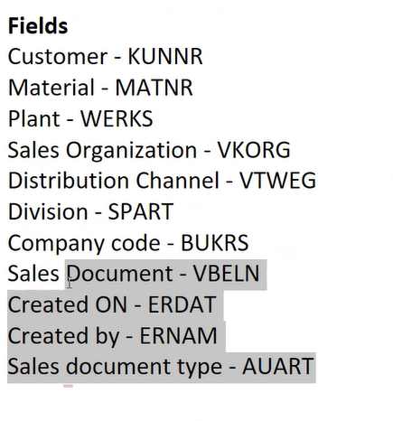
* **SU01 –** Complete profile of person
* **SPRO –** SAP Project Related Object – Configuration
* **EC01 –** Structure Navigation
* **XD01 –** Customer Master data
* **VD01 –** Don’t have comp code view other 2 will be there(general and sales).
* **FD01 -** only finance related will be there.
* **MM01 –** Material master
* **VA11** - Create Inquiry, change-> VA12, Display->VA13, List->VA15n
* **VA21** - Create Quotation, 22, 23 , 25n
* **VA01** - Create Sales Order, 02, 03 , 05n
* **Va31 –** Scheduling Agreement
* **VA41 –** Contracts, quantity and value(mat rel and general)
* **VL01n –** Delivery create, vl06f -> list
* **VL10A/C –** Combine 2 orders into 1 delivery.
* **MB1C –** To give stock for material
* **MMBE –** Total stocks in sloc for material.
* **VOV8 -** Creating new sales document type(in, qo , or …)
* **Vk11 –** maintenance of condition record (For tax)
* **OVL2 –** Shipping point determination
* **OVL3 –** Picking location determination
* **V/08 –** Pricing procedure
* **v/06 –** Condition type
* **V/07** – Access Sequence
* **VV11 –** Output for sales order
* **VV21 -** Output for delivery order
* **VV31 -** Output for billing
* **wsv2** – assortment module
* **VTFA -** OR to F2 copy control
* **Me21 –** creating purchase order
* **XK01 –** create vendor
* **We02 –** idoc
* **Vfx3** – mass invoice to accounting
* **VOFM –** Routine.
* **VKOA** – Account determination
* **CMIR(VD51)** = customer material info record
* Translate customer terminology to company terminology
* **VKM3  -** to release sale order which got credit exceed
* **Fd31** – is not there. it is already set to zero. always set to zero.
* **Fd32** – just change credit limit .

Client specific – functional

Cross client - ABAP

First SD-FI :- sales org to company code.

1. Next Customer master give reconciliation account(g/L), then bill to party payer, payment term, incoterm, pricing. Credit check, Account key and accrual (pricing procedure)

First SD-MM :– sales org , dist channel to plant.

When creating material master with sales view.

1. Availability check

2. Delivery PGI (Inventory-MB1C)

3. MRP(MTO) – 3rd party scenario

4. Movement type (Schedule line)

**Sales doc checks and control**

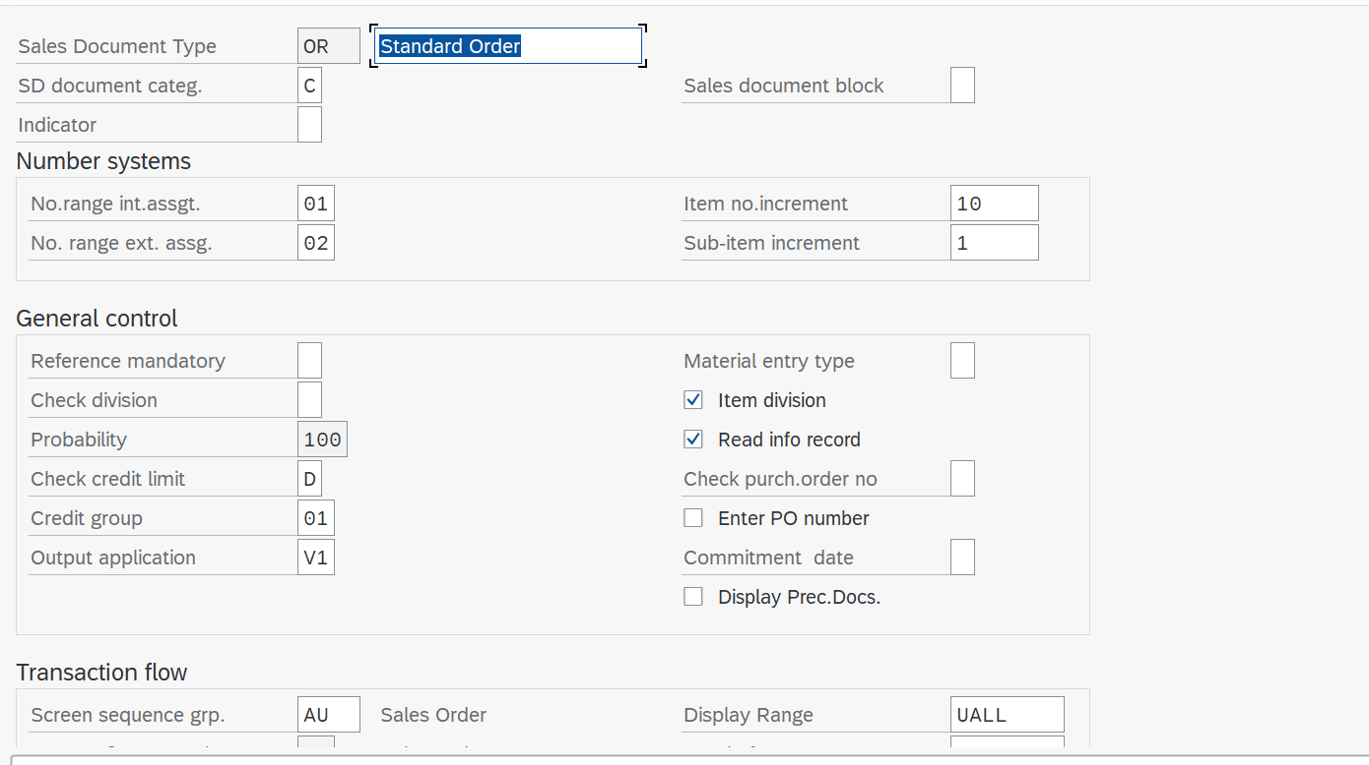

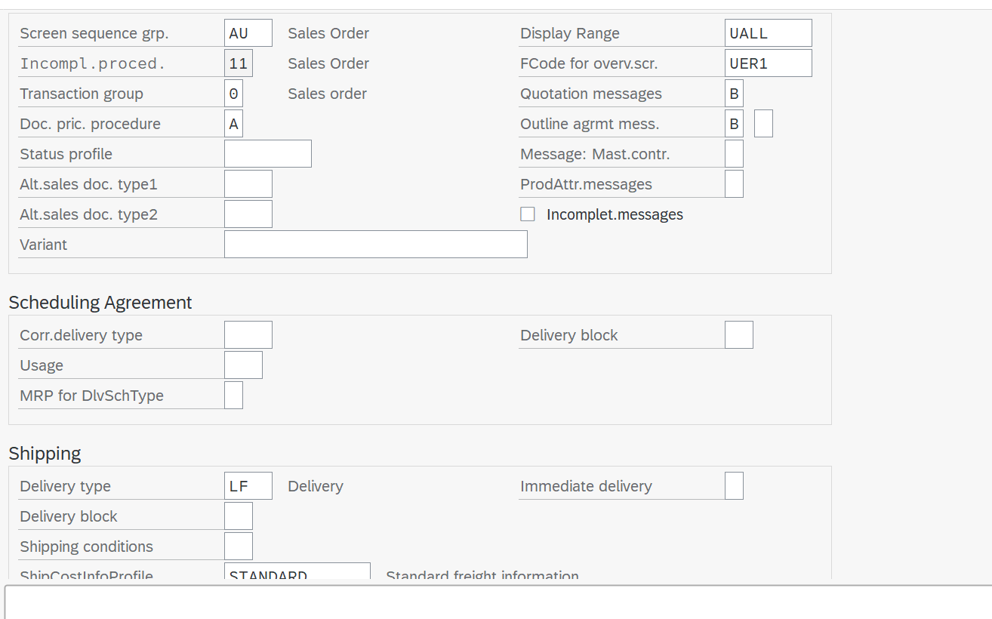

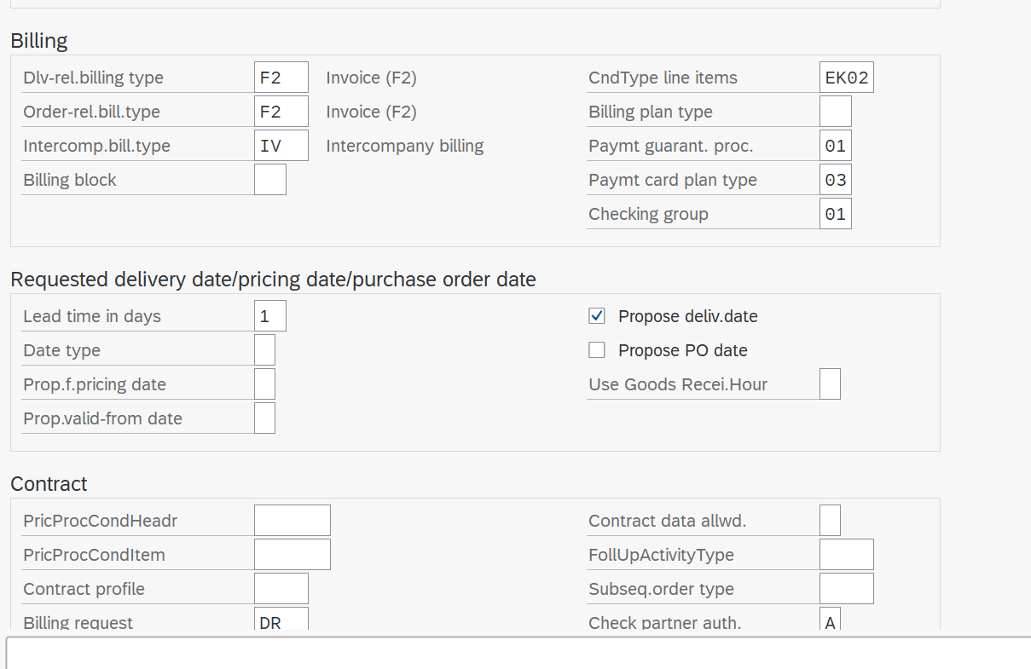

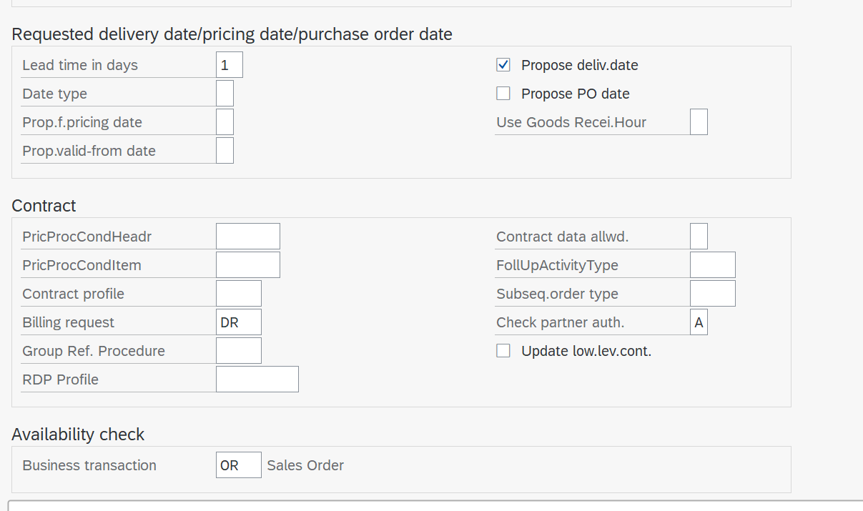

**Billing checks and control**

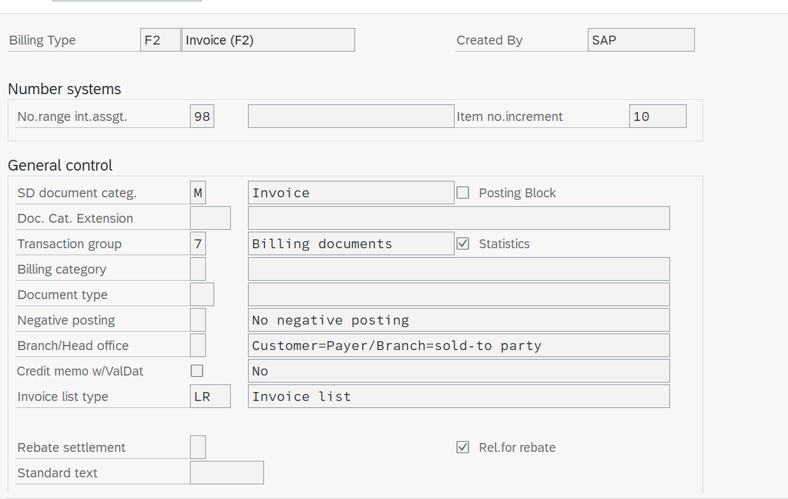

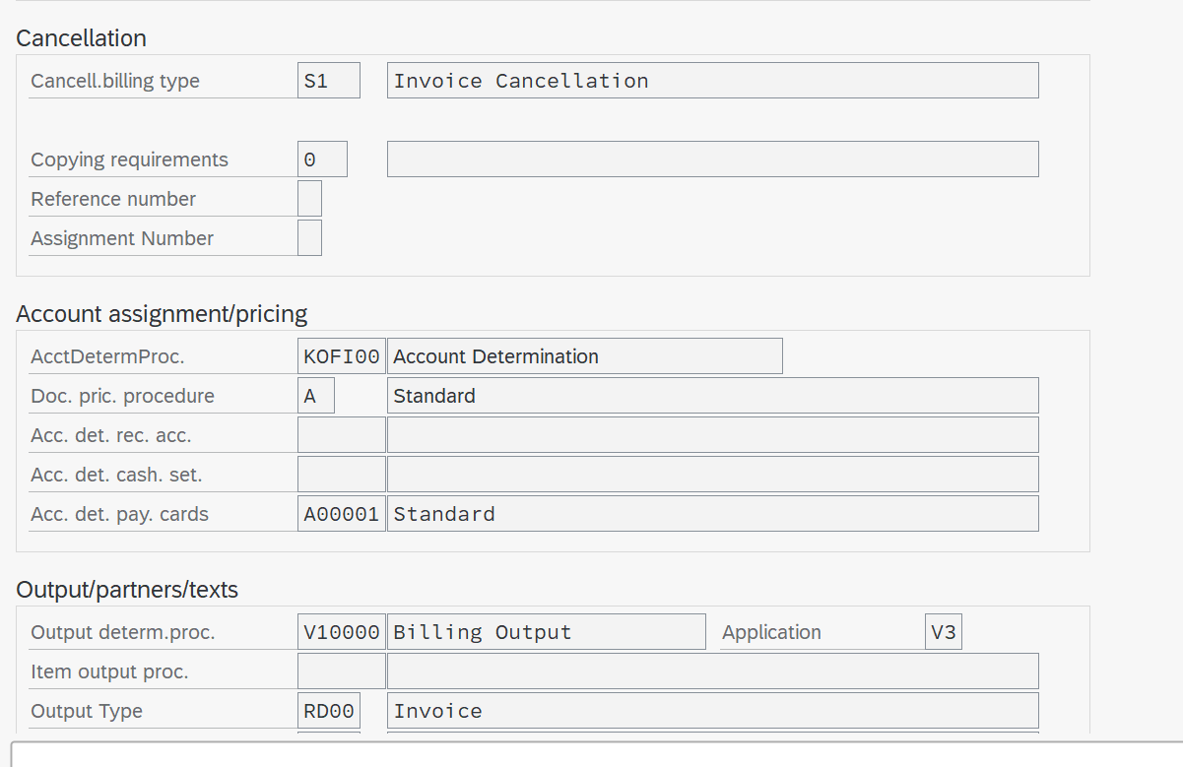

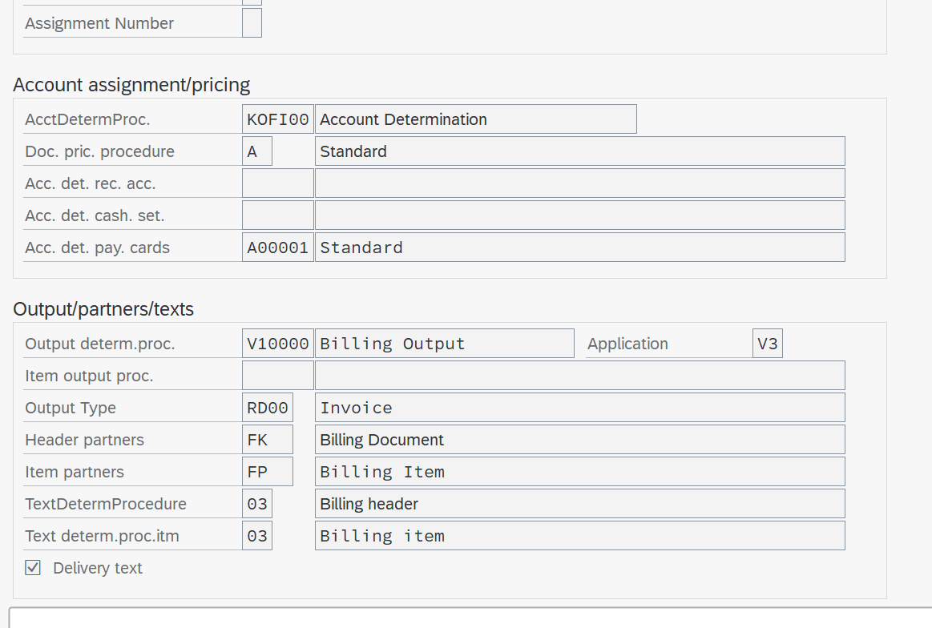

Delivery checks and control

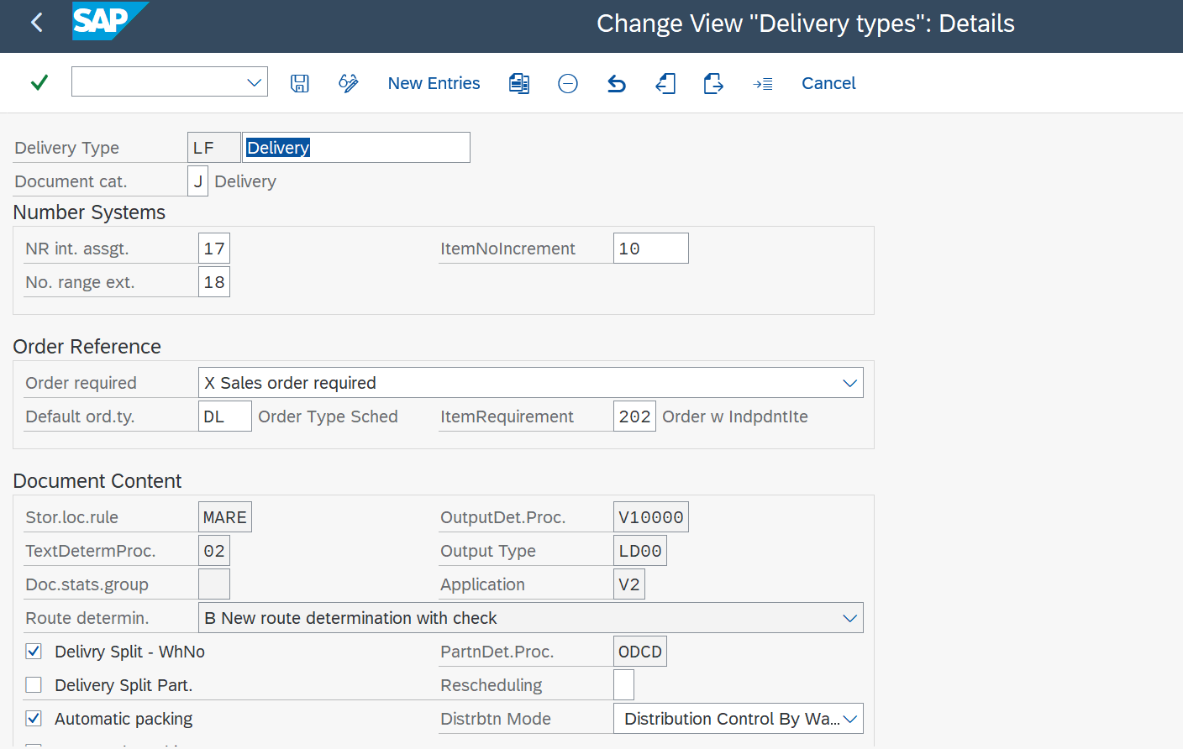

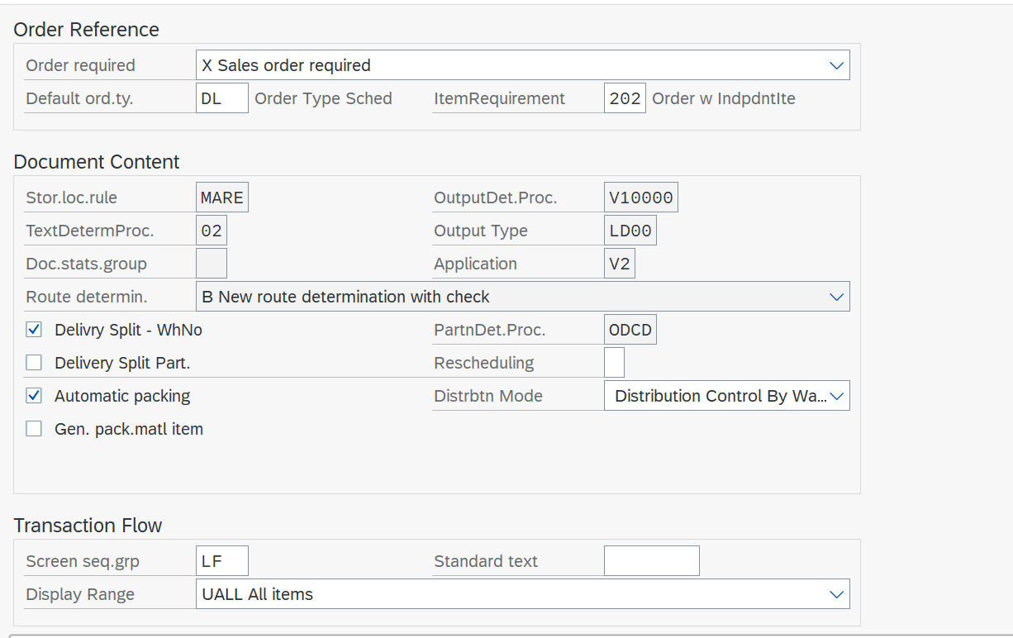

**Item cat checks and control**

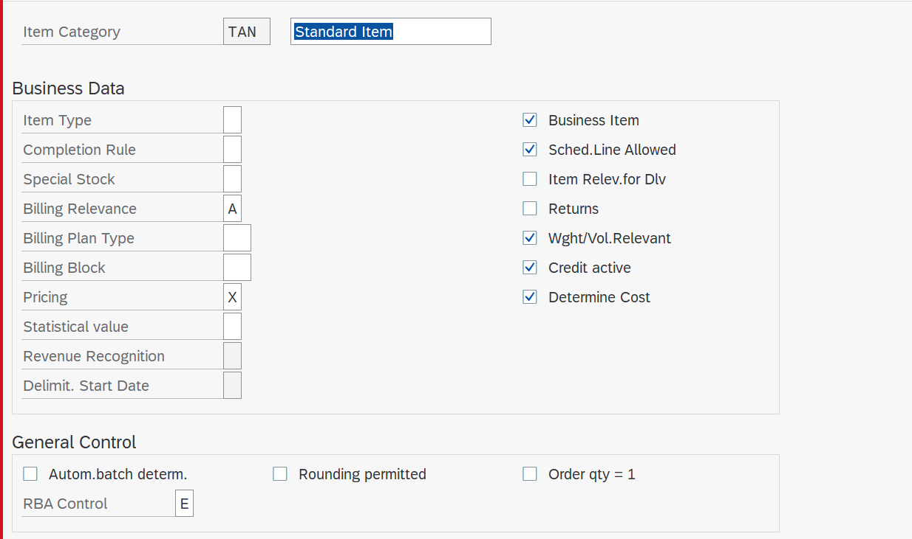

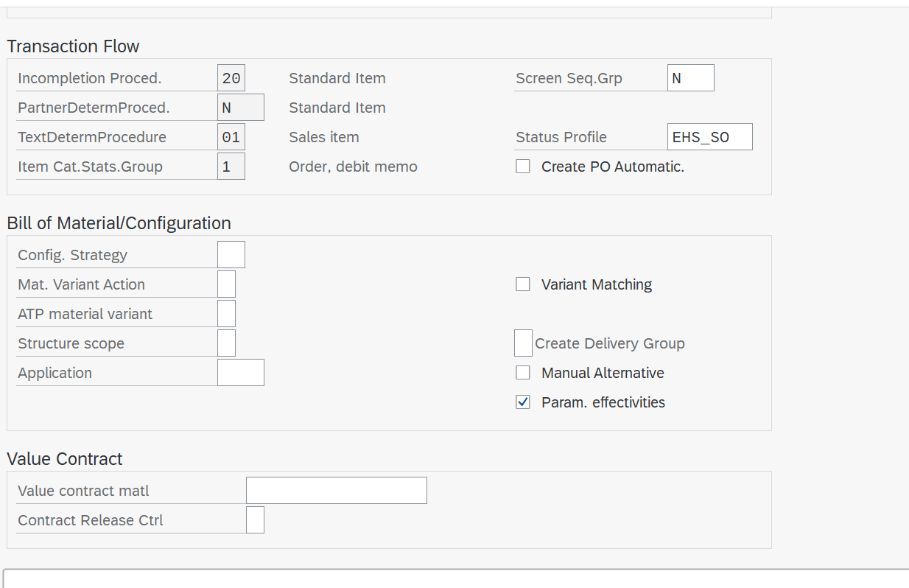

**Schedule line checks and control**

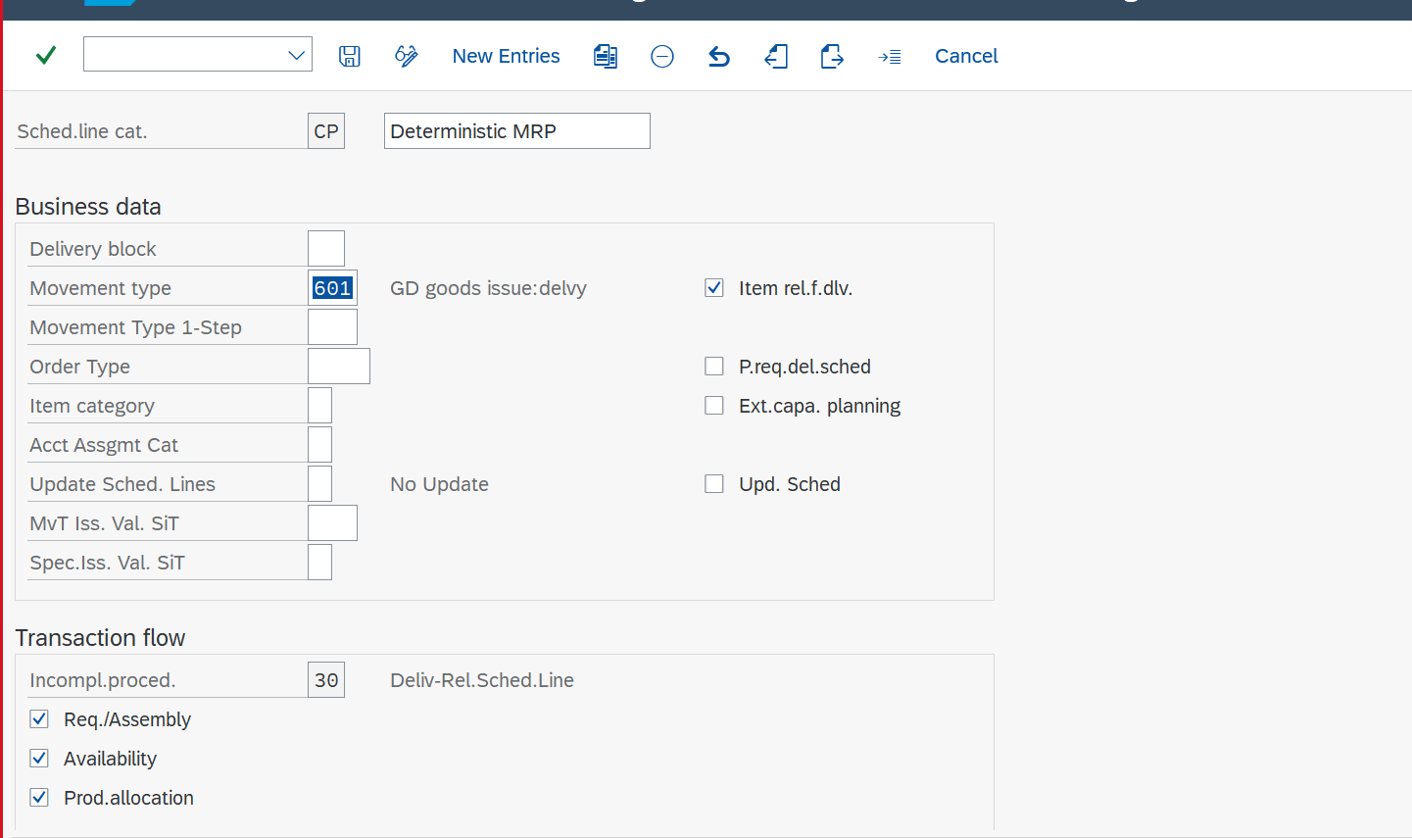

**Condition type checks and control**

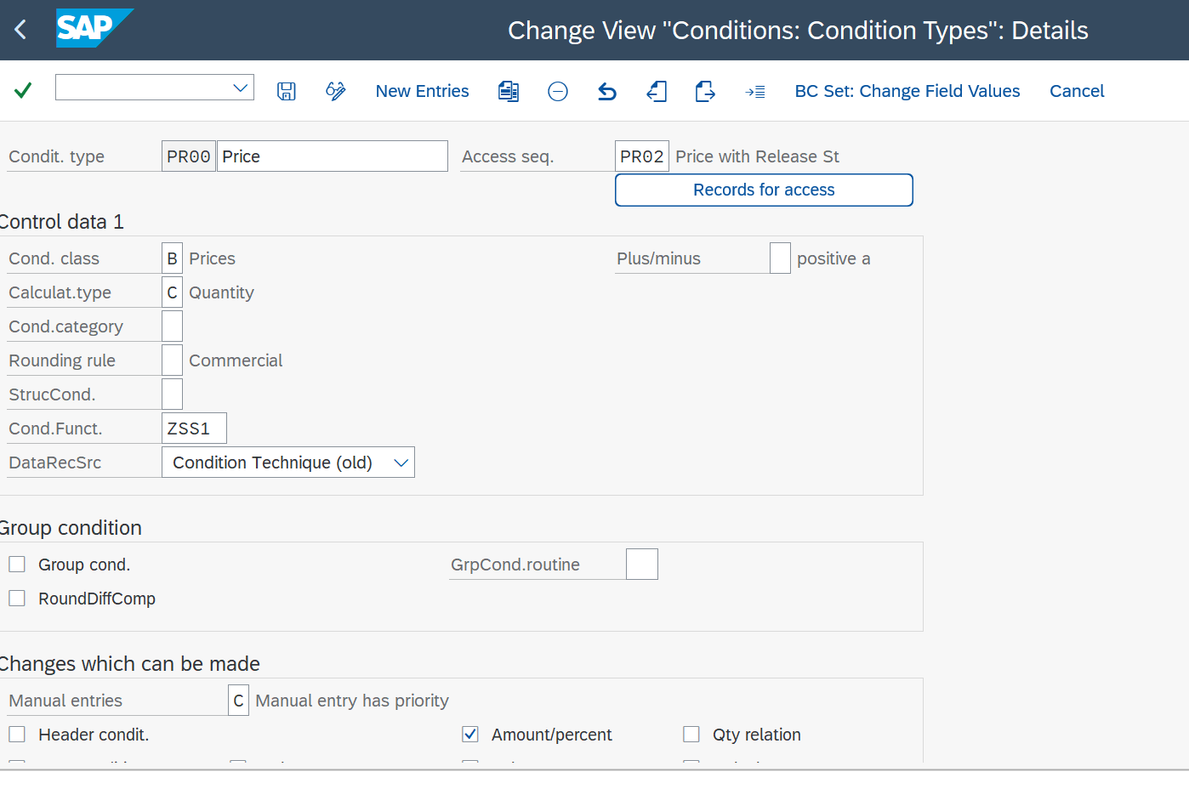

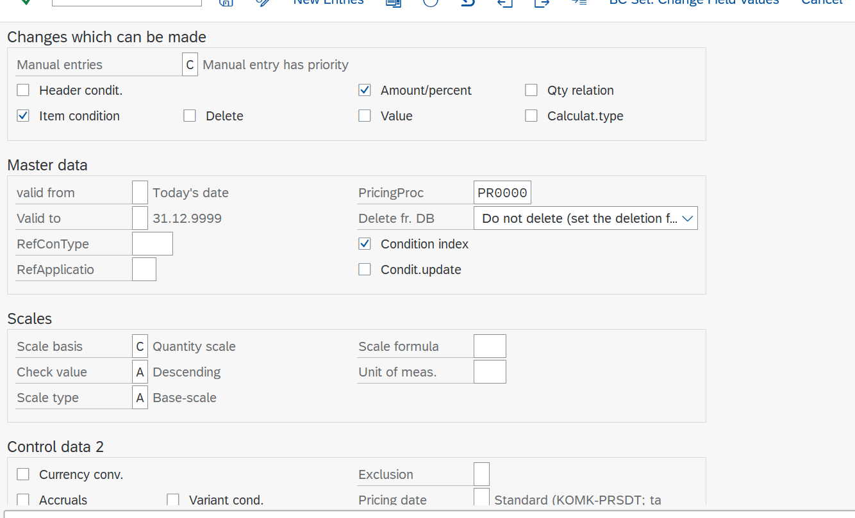

Menu bar, tool bar, status bar  -> in **main screen**

**Company code** – we can see profit and loss(FI)

**Plant** – manufacturing material, keeping stock.

**Division** – Product Categories(2 wheeler -> motorcycle - scooter) (MM)

**Finance** – Credit & Debit.

**Controlling** – Cost of Production (From raw material to final product).

**Storage location** – Inside plant

**Sales Area** is nothing but sales org (SD), distribution channel and division.

If we want to sell anything this 3 must be assigned.

1 plant can have many shipping point

Sales org -> comp code = SD FI

Div –> sales org = SD MM

Distri channel -> Div –> sales org = MM link.

Distribution channel à through which products and services of an org to reach the customer.

**Company-to-Company code:** One Company can have many company codes. But one company code has to be

assigned to one company. So the relation is **one to many**.

**Company code to Sales Organization:** One company code can have many sales organizations. But one sales

organization has to be assigned to one company code. So the relation is **one to many**.

**Sales Organization to Distribution Channel:** One sales organization can have many distribution channels. One

distribution channel can be assigned to many sales organizations. So the relation is **many to many**.

**Sales Organization to Division:** One sales organization can have many divisions. One division can be assigned to

many sales organizations. So the relation is **many to many**.

**Distribution Channel to Division:** One distribution channel can have many divisions. One division can be

assigned to many distribution channels. So the relation is **many to many**.

**NOTE:** Division is always sales organization specific.

If sales organization wants to use a plant that plant must be assigned to sales organization.

**Definition**

SPRO – SAP IMG reference - Enterprise Structure – Definition- Logistics – General- (Logistics – General) – (Plant, division)

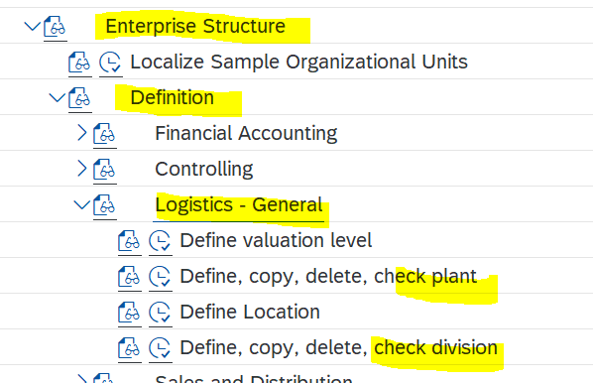

SPRO – SAP IMG reference - Enterprise Structure – Definition- (sales and distribution ) – (sales org , distribution channel)

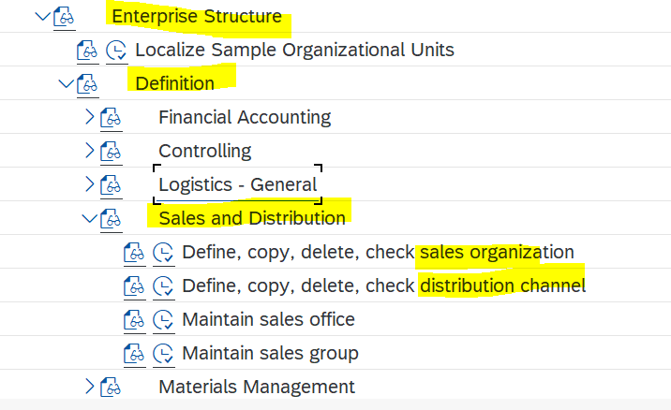

SPRO – SAP IMG reference - Enterprise Structure – Definition- (Materials Management)

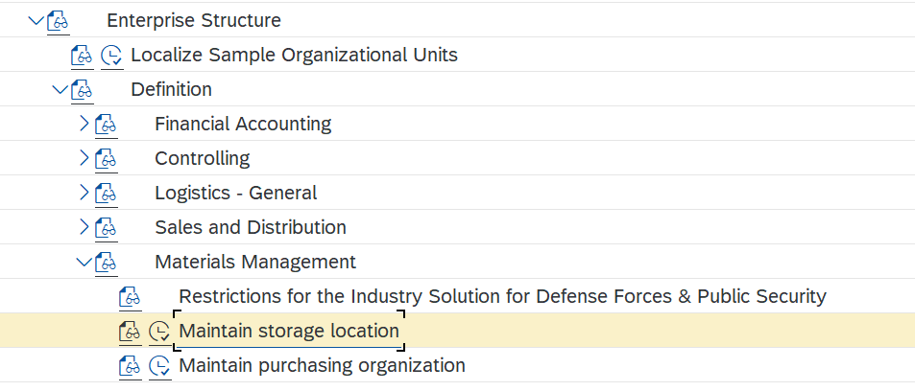

SPRO – SAP IMG reference - Enterprise Structure – Definition-( Logistics Execution) – (Shipping point)

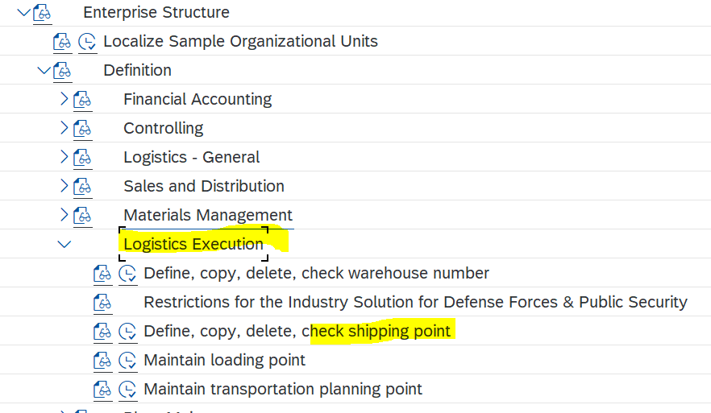

**Assigning**

SPRO – SAP IMG reference - Enterprise Structure – Assignment-( Logistics general) – (plant to company code)

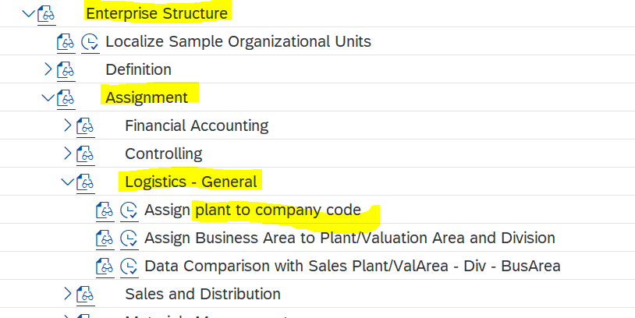

SPRO – SAP reference IMG - Enterprise Structure – Assignment-( SD) – (sales org->comp code, distribution chn->sales org, div->sales org, sales area, Assign sales organization - distribution channel - plant)

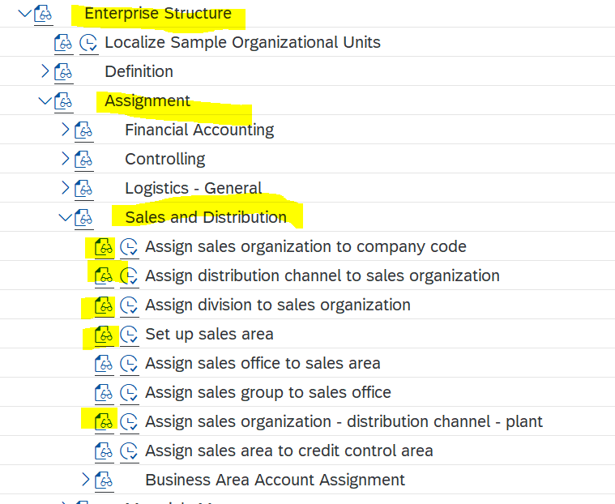

SPRO – SAP reference IMG - Enterprise Structure – Assignment-( Logistics Execution) – (Assign shipping point to plant)

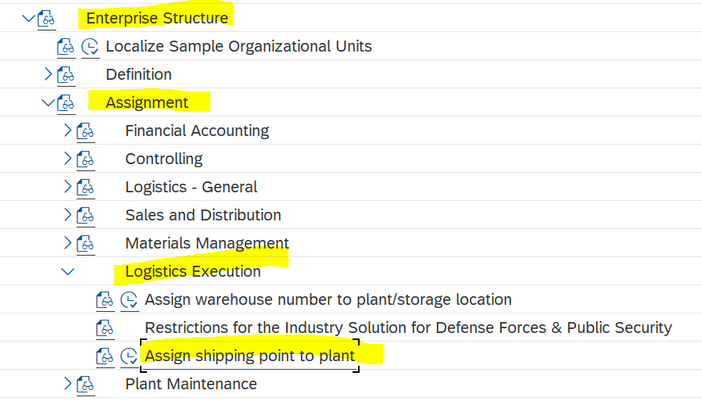

**XD01 –** Has 3 View (Customer)

* **General view**
* **Company code data view** finance related, interest, payment method, insurance etc.
* **Sales Area data view** à sales related data(sales-cust.pric.pro, price list, item proposal),(shipping- shipping condition, delivery plant), (billing- Cust acc assgn group, incoterms, payment terms, tax, credit contr area),(partner functions- sp, sh, bp, py)

**Partner function  :**

* Sold to party à SP
* Ship to party or goods recipient à SH
* Bill to party à BP
* Payer à PY

**XD01**

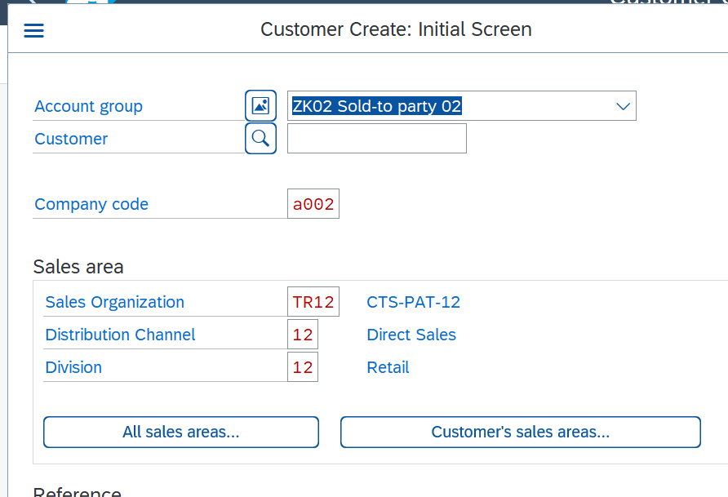

Currently in general view

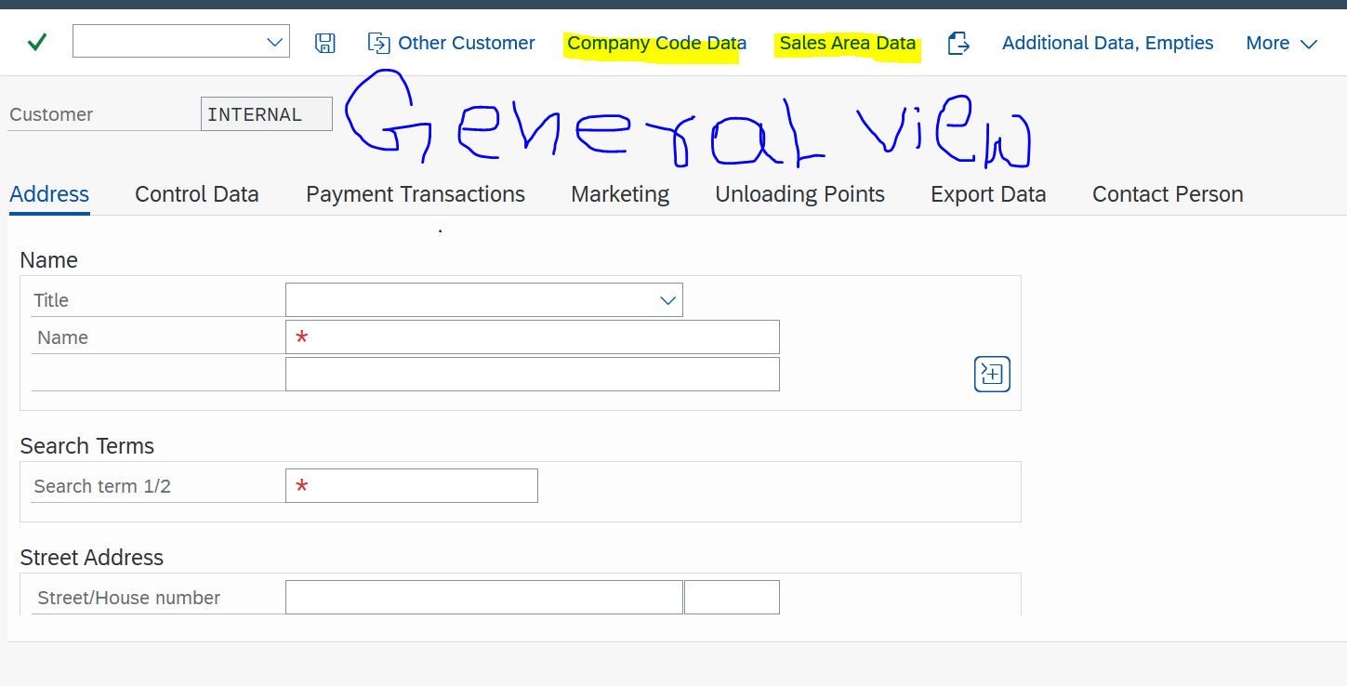

Company code view (G/L account)

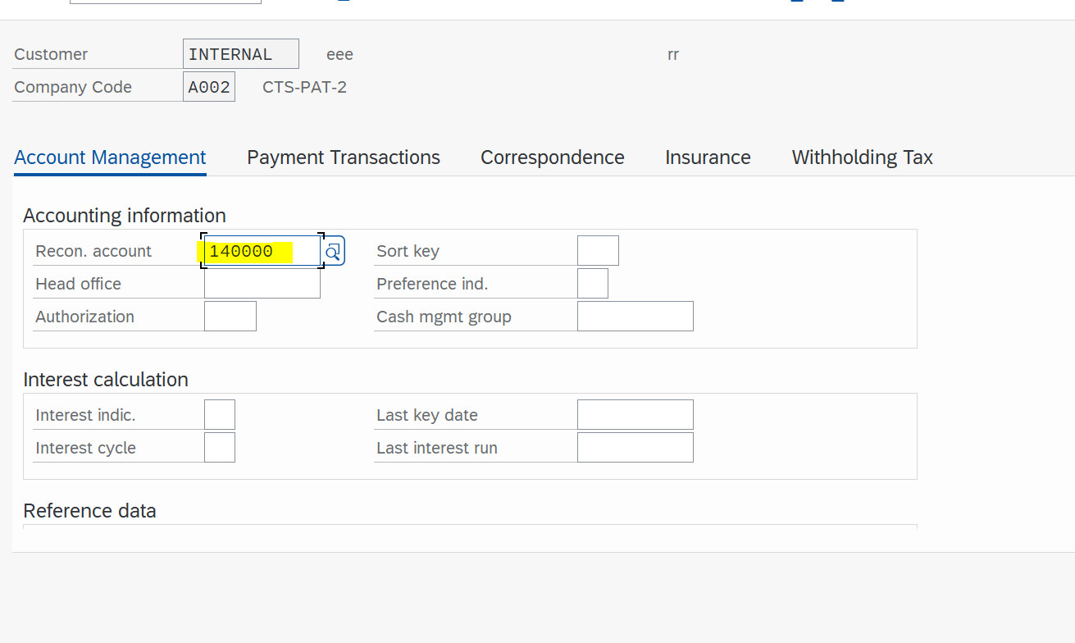

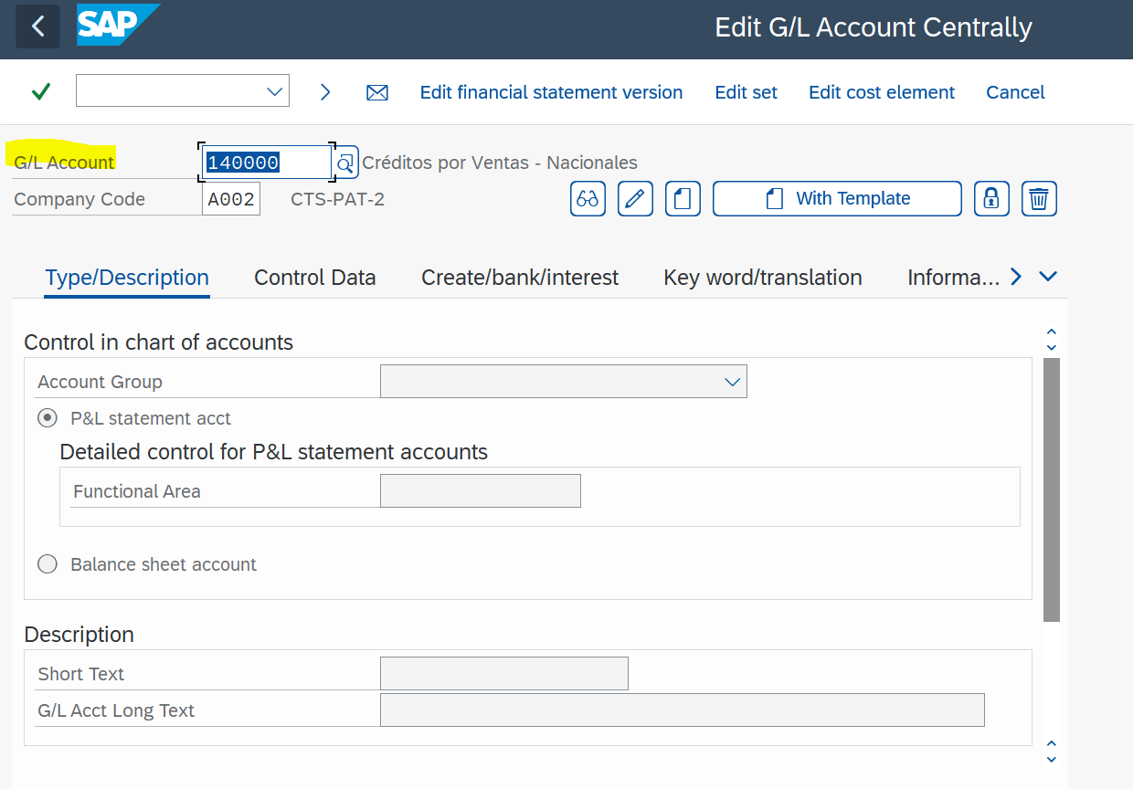

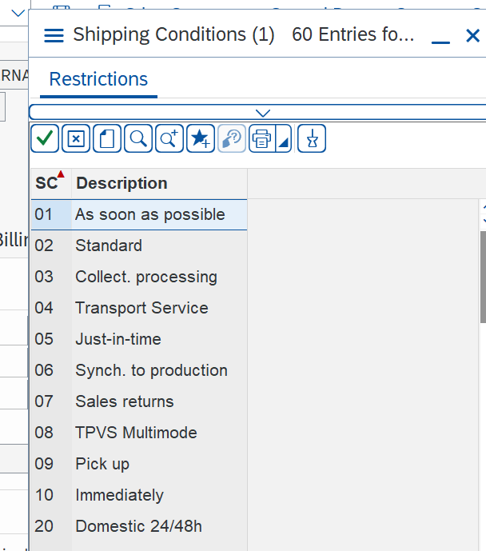Sales view

Sale- Currency – INR,

Ship-shipping condition – 01(as soon as possible)

Bill- inco terms of pay (cfr) (0001-Payable immediately Due net)

Sales – cust.pric procedure, price list

There are three levels in sales order:

1. Header level – Sales document type

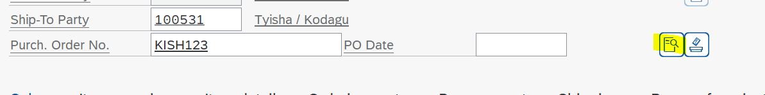

1. Item level – Item Category

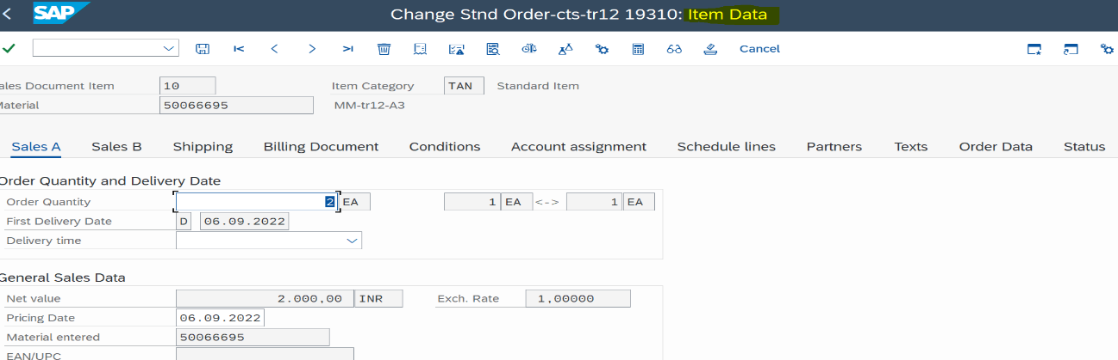

3. Schedule line Level – Schedule line category

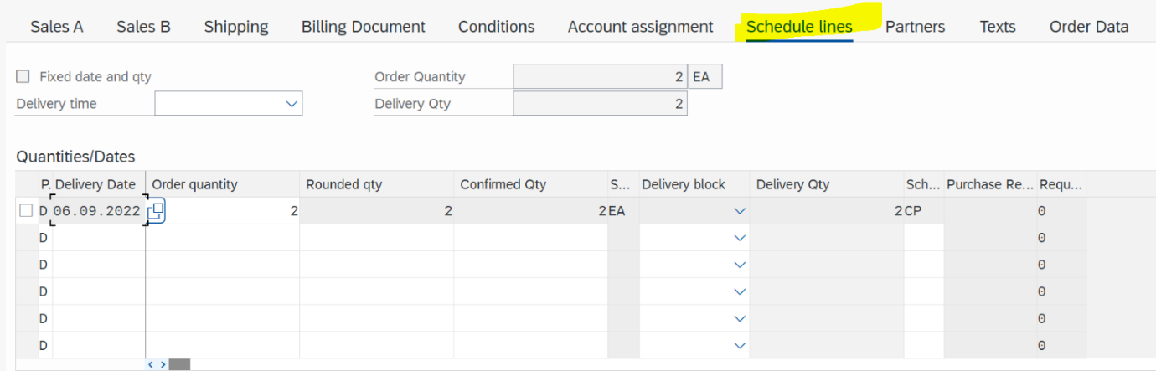

**Some of the basic sales functions are as follows:**

 · Partner determination

· Pricing

 · Output determination

 · Text determination

 · Material determination

 · Credit management

 · Incompleteness

 · Delivery scheduling

**Different types of sales doc type**

**Pre- Sales**

IN = Inquiry

QT = Quotation

**Outline Agreements**

QC = Quantity contract

DS= Scheduling agreement

QP= Rental Contract

WK1= General Value contract

**Post Sales**

OR = Standard Order

RO= Rush order

CS = Cash Sales

CF = Consignment Fill- up

FD = Free of charge delivery

**Complaints**

RE= Returns

CR = Credit Memo request

SDF = Free of charge subsequent delivery

DR = Debit Memo Request

**Consignment**

CF- Consignment Fill-up

CI-Consignment Issue

CONR - Consignment Returns

CP-Consignment Pick-up

Sd doc categ.

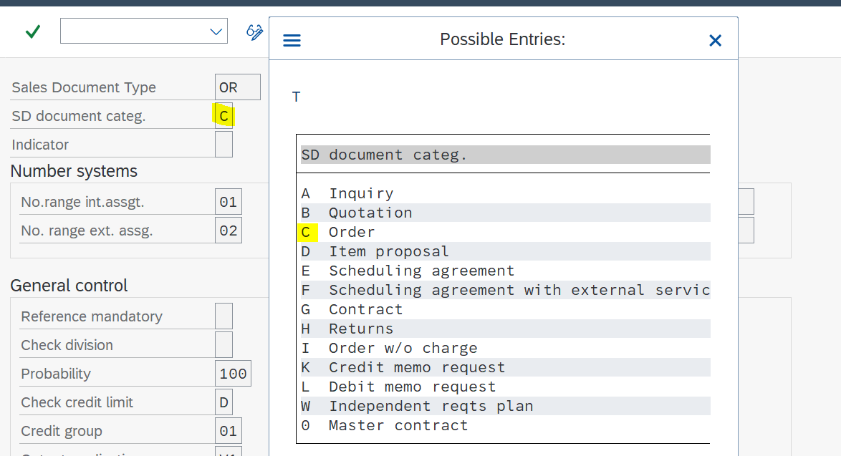

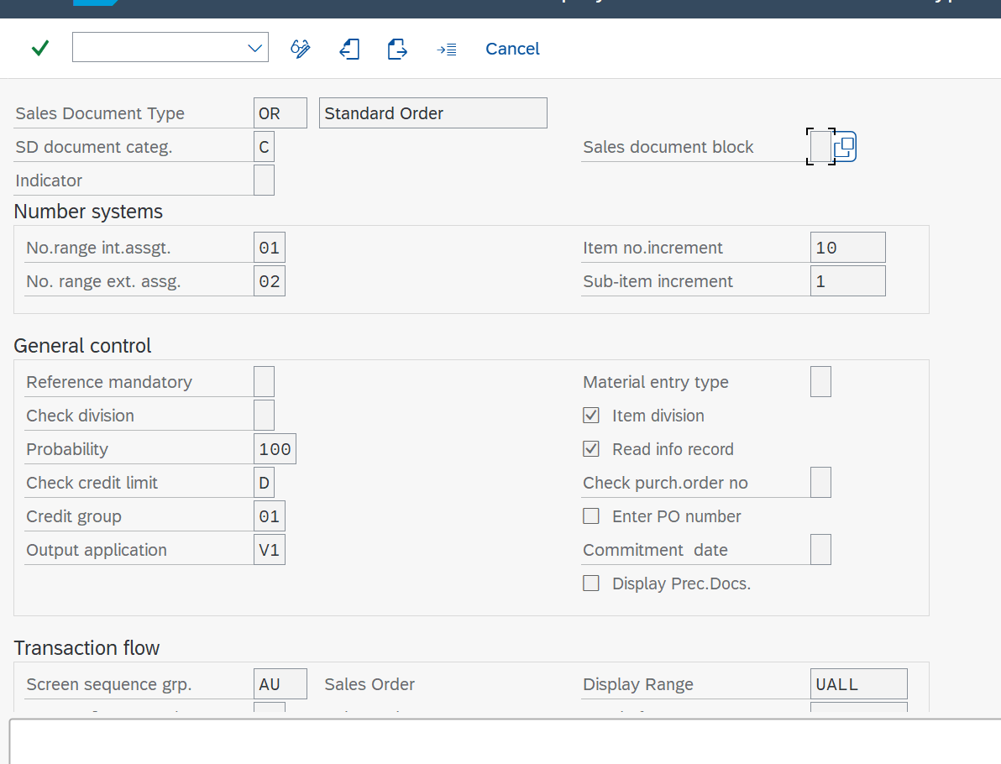

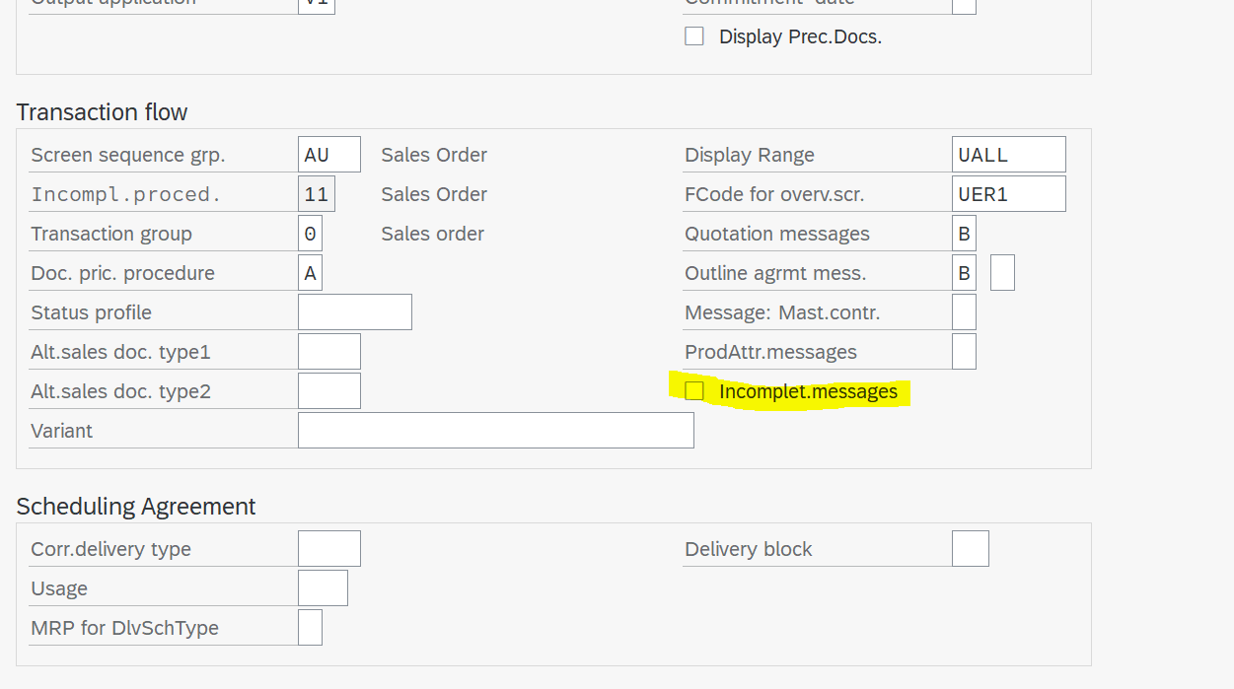

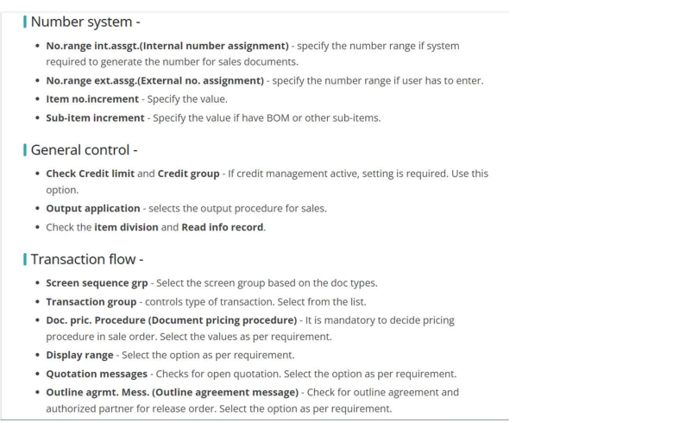

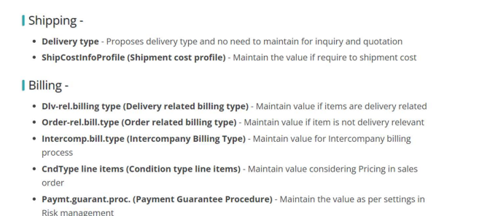

**ITEM CATEGORY** – controls the line item in an order (sch line allowed, billing relevance, credit active, pricing)

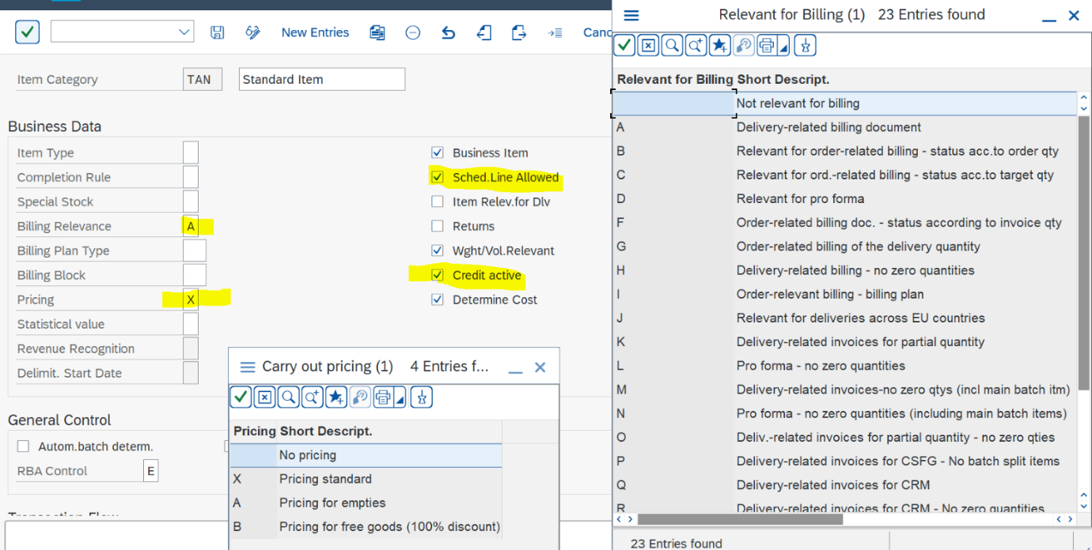

The SAP provides various item categories to model the business processes. The standard item categories can be used as template or create your own item category to address business requirement.

 The item category controls the way an item functions in the sales document and in any subsequent processing for the business transaction

 First two characters of the four digit key provides a clue to the sales document

The last two characters of the four-digit key indicate the use of the item category.

Essential characteristics of an item category

Relevant for pricing

Relevant for billing

Text item

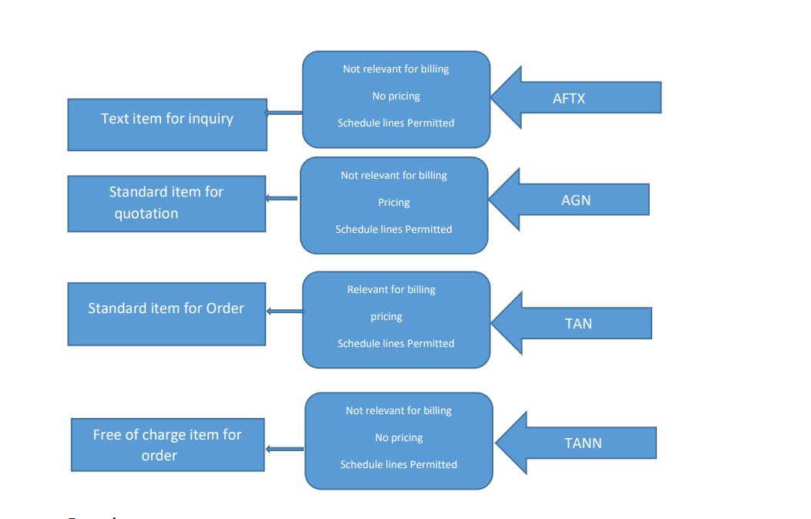

**Examples**

AFTX -The sales document type is IN and the usage is TEXT

TAD -The sales document type is OR and the item category group is LEIS

TAN- Standard item for the order

TAS – Stand item for 3rd party

KMN- The sales document type is QC and the item category group is NORM.

**Pre- Sales**

AFN=Standard item in Inquiry

AGN = Standard item in quotation

AGTX= Text Item in quotation

**Outline Agreements**

KMN = Standard item in quantity contract

WVN= Standard item in Maintenance contract

WKN =item in Value contract

**Post Sales**

TAN =Standard item in sales order

TAD = service item in standard order

BVVN= Free of charge item in Cash sales

KEN =Standard item in consignment Complaints

REN= Standard item in returns

G2TX= Text item in credit memo request

**BOM**

 Item category group (ERLA) = Main item TAQ (Priced) and sub item TAE (not priced) Item category group (LUMF) = Main item TAP (Not Priced) and sub item TAN (priced)

**Item category determination**:

 Sales document type + Item category group + Usage + Higher level Item Category

OR +NORM+FREE+ TAN

**Tables**

VBAK - Sales document header

VBAP – Sales document item

VBEP – Schedule line categories

**Config table**

TVAK -Sales Document Types

TVAP- Item Categories

TVEP- Schedule Line Categories

 Order to cash (O2C) : 

Inquiry-VA11/VA15N / Quotation-VA21 / Sale Order-VA01 / Delivery-VL01N-VL06 / Billing-VF01**.**

Free of charge delivery 

Credit Note-CR(VA01)

Debit Note-DR(VA01)

Return Order-RE(VA01)

Contracts- QC (VA41)

Scheduling Agreements-DS(VA31 , VA35N)

Consignment process-CI/CF/CONR/CP**( Sale order àDelivery)**

**CF: Consignment Fill up**

**CI: Consignment Issue (**Here only billing is there .)

**CP: Consignment Pickup**

**CO: Consignment Returns**

**Sale order àVA01**

Here we will give Sold to , ship to , material , order no , quantity, weight , plant , storage location ,incoterms and payment terms details , inside material condition we will give the pricing details and check the incompletion log and save the sale order.

After that we do the PGI , delivery (VL01) and billing (Vf01).

**Customer-Material Info Record (VD51) :**

It is used to connect with the Legacy data.

The following are the key transaction related to SAP Customer-Material Info Records:

* **VD51** – Create Customer-Material Info Record
* **VD52** – Change Customer-Material Info Record
* **VD53** – Display Customer-Material Info Record
* **VD54** – Display for Material
* **VD59** – List Customer-Material Info Records

**Billing – (SD billing)**

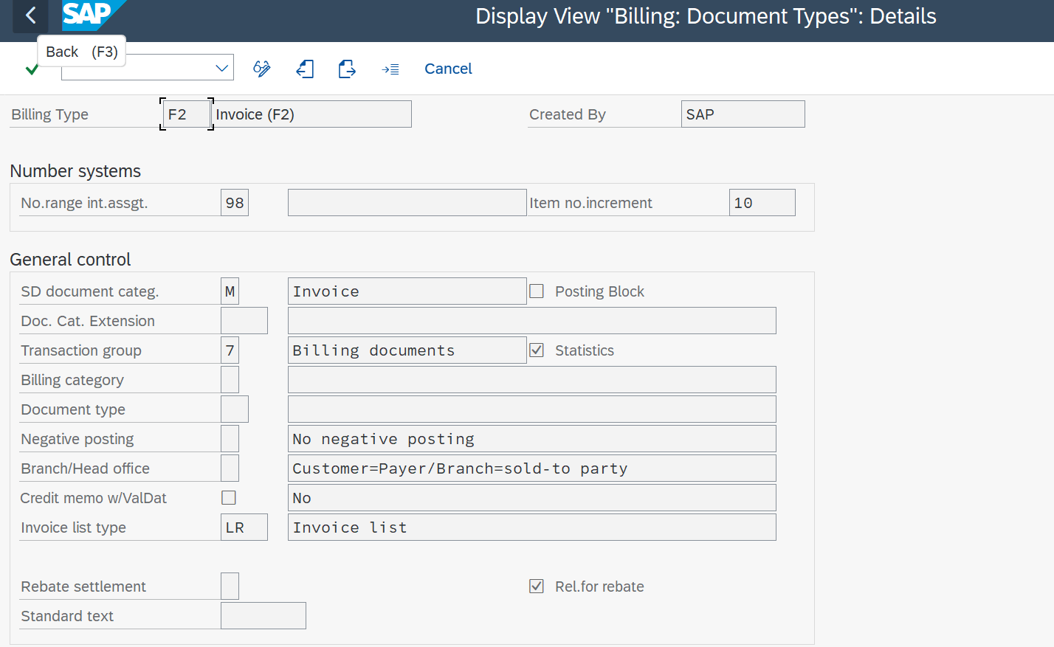

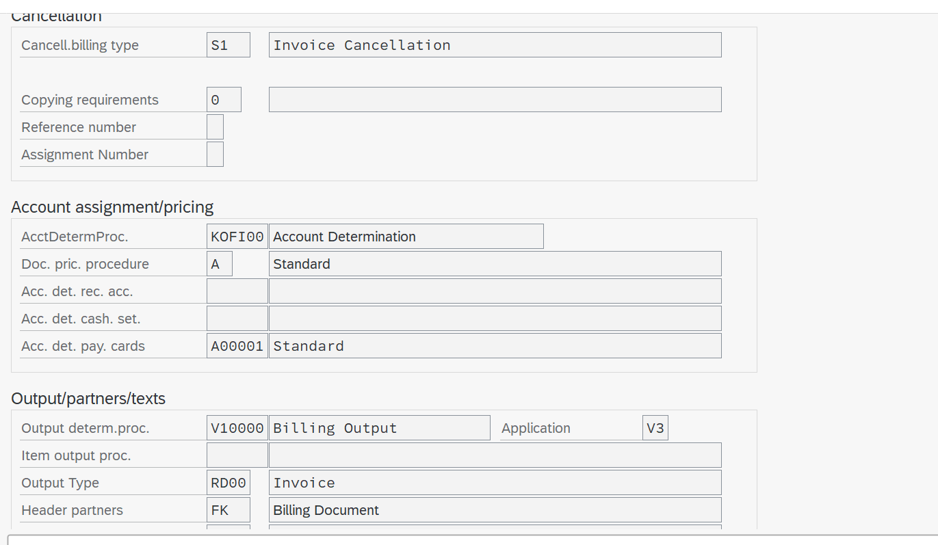

1. Create order / quotation with below document types and fill the information in the blank fields Use first two row as reference and fill other rows.

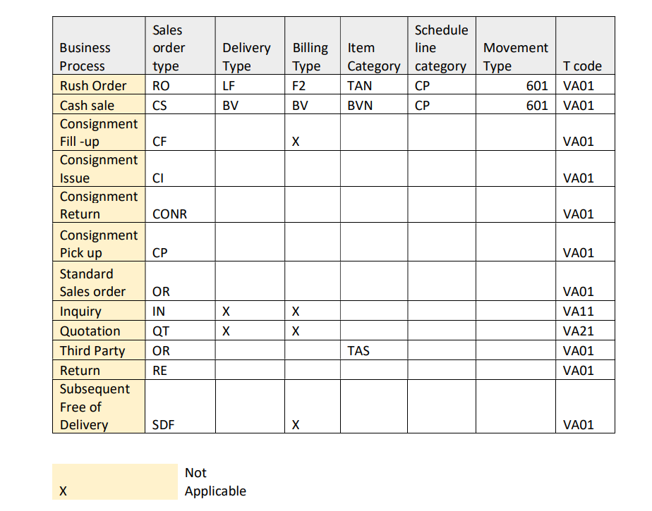

Go to yours inquiry(inxx) -> add require details (material and customer) -> you can find out item category in row you added material -> to check schedule line cat -> double click material -> schedule line -> can see the sch line cat -> to see movement type vov6 -> search your (inxx , qtxx and orxx ) ->double click -> and write down..

Note: if there is no movement type just be it blank..

2 .  Create documents with below quantities and use create with reference option. Check the significance of completion rule control of the item category. Inquiry with 100 quantities Quotation with 50 quantities Order with 25 quantities..

Just do whatever asked in question -> then after done with order -> va02 -> give recent  order number -> in tool bar go to document flow -> check all the status ->

Ex : inquiry completed

       Quotation ( check )

      Order (check the status)

1. Create your own item category and determine in the sales order

Vov7-> copy TAN -> change name as TAXX -> save -> spro -> sap ref  img -> sales and dist -> sales -> sales doc -> sales doc item-> assign item cat -> give your sales doc type(orxx) and item cat group (NORM)->  make changes in your sales type here taxx and tan  .

Next search it like this (orxx , NORM , TAN) -> copy and change H level cat to TAxx and default TANN à save..

1. Vov6 -> copy CP to change that your choice name whatever it may be but description must be meaning full..-> then go as shown in snap

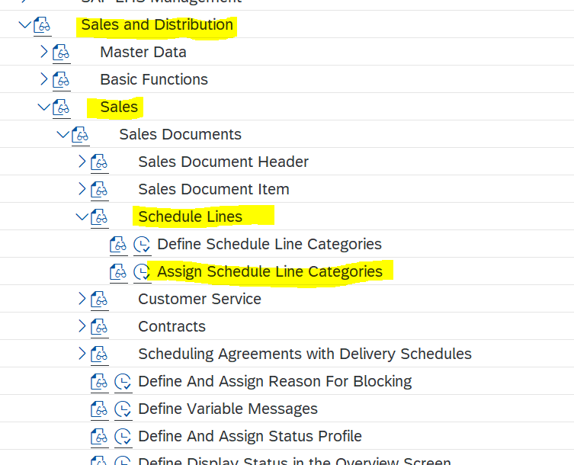

**Pricing procedure v/08**

For Pricing procedure determination, we need to do one step before pricing determination is Maintaining the Condition Types .

IN VK11 we maintain the condition records .

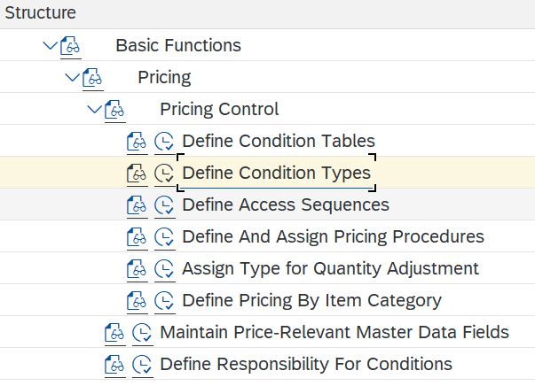 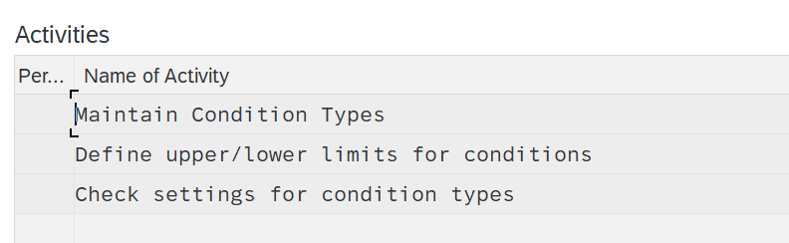

 Here copy the existing  Ctyp or go for the new entries to create the new one .

ZP10 for Price,

ZF10 for Freight,

CGST, SGST for tax.

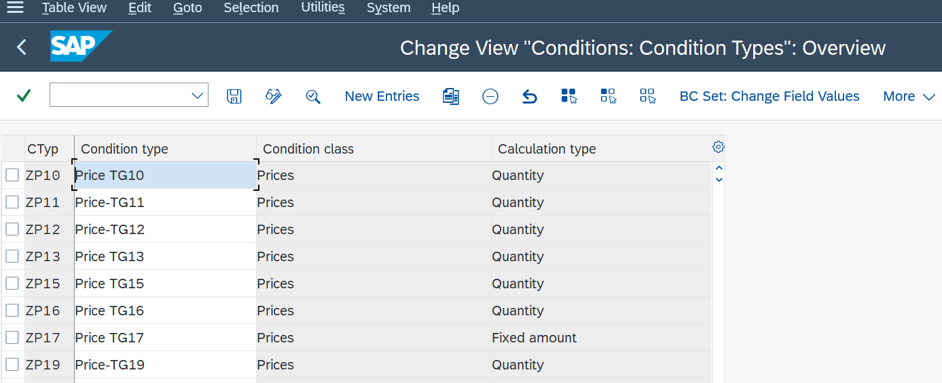

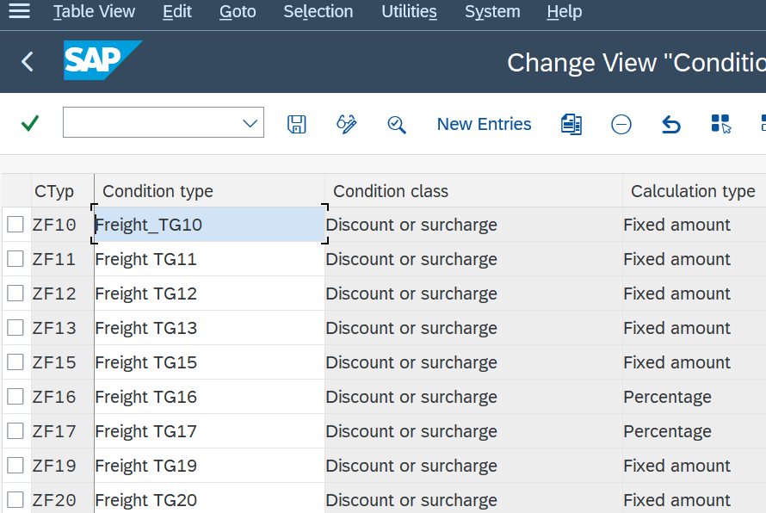

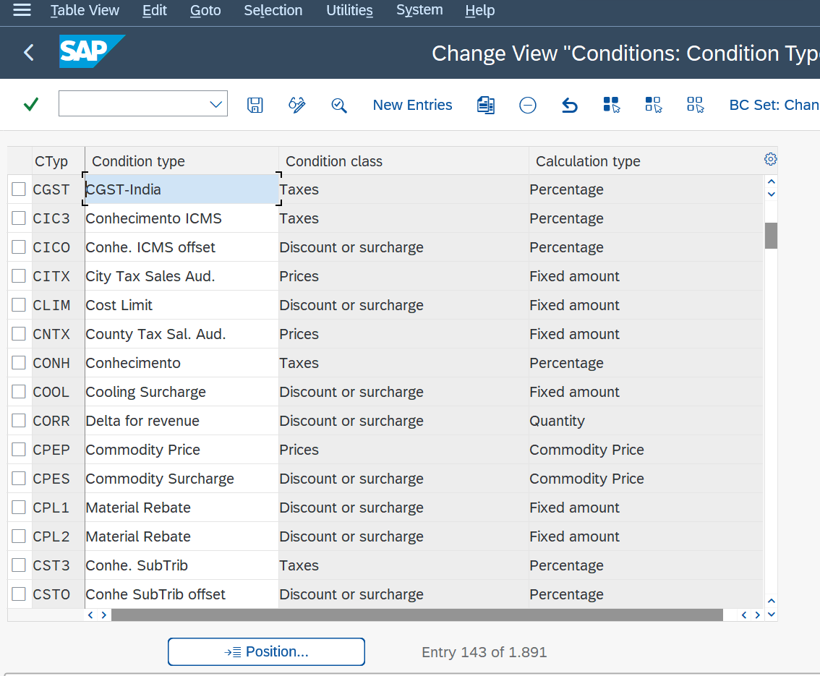

**Now we will Define and Assign the Pricing procedure**

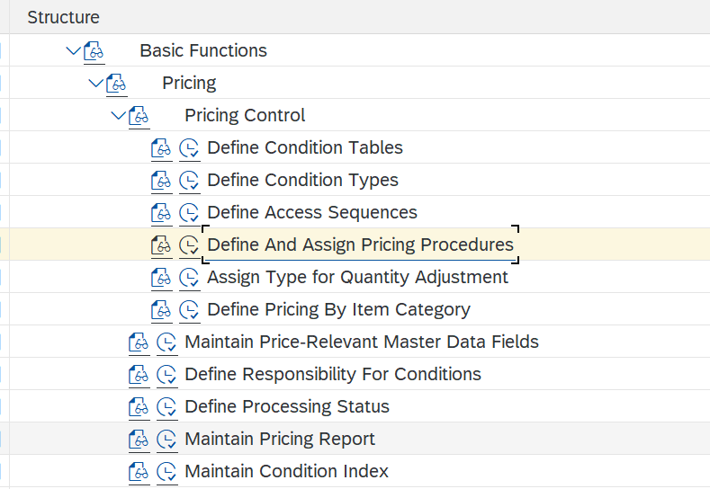

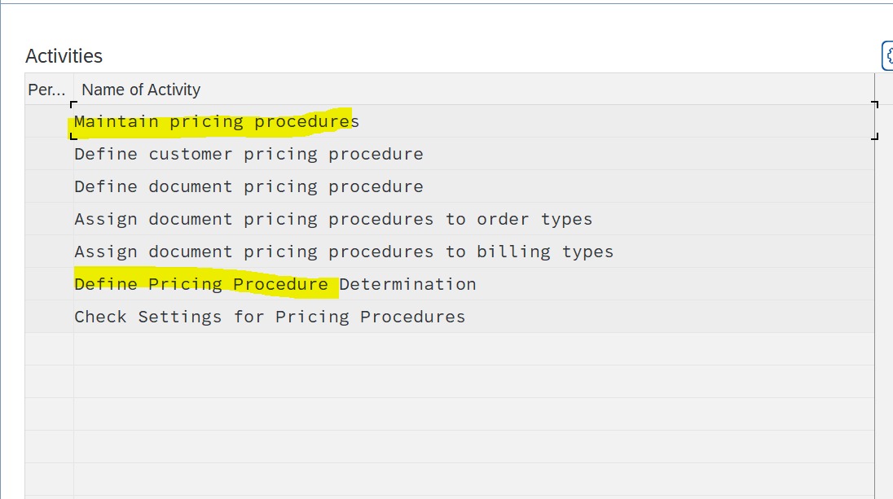

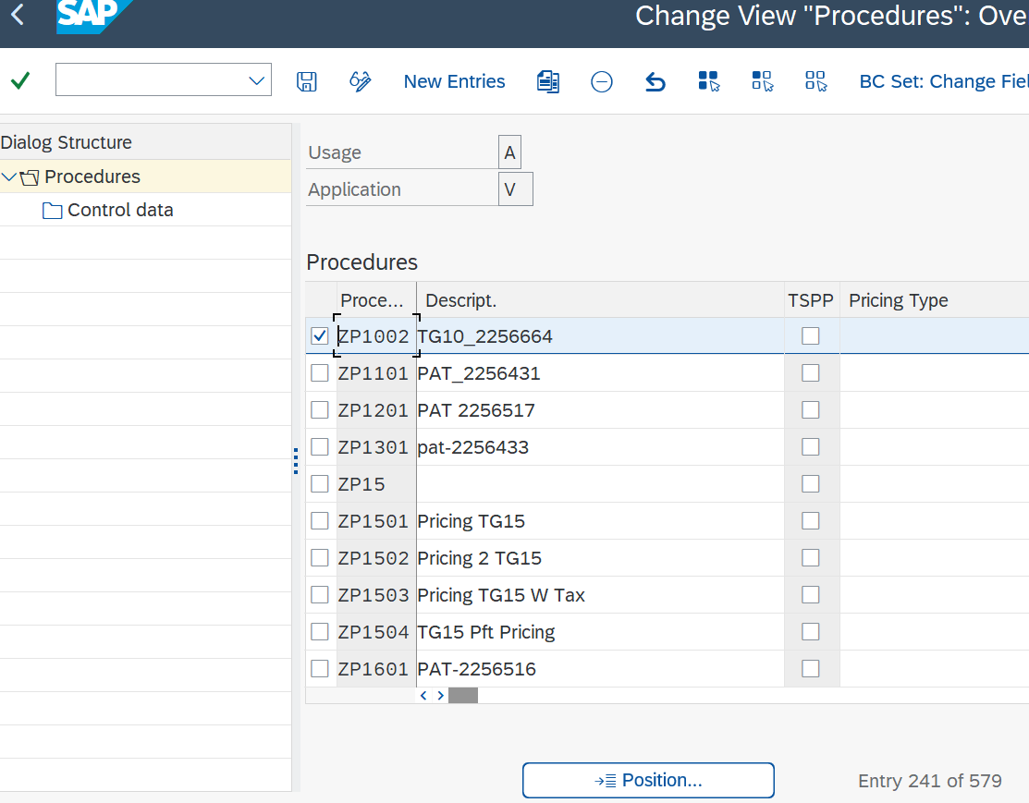

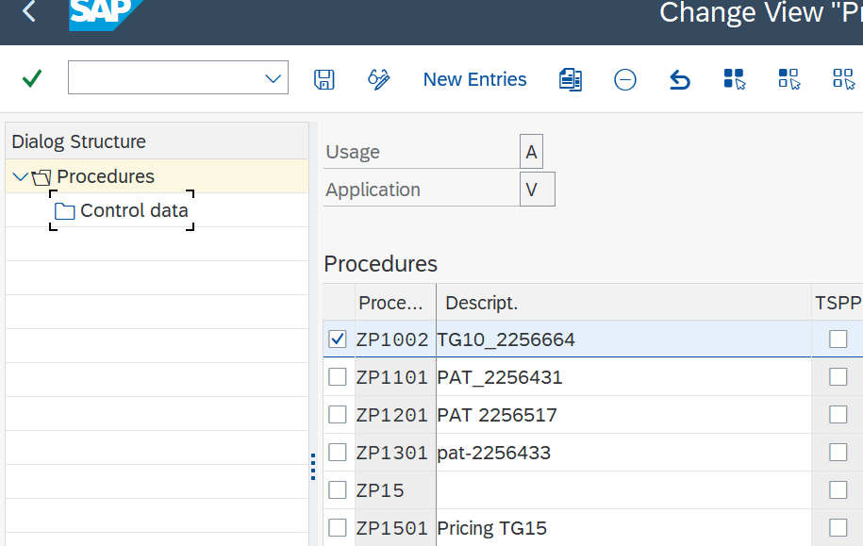

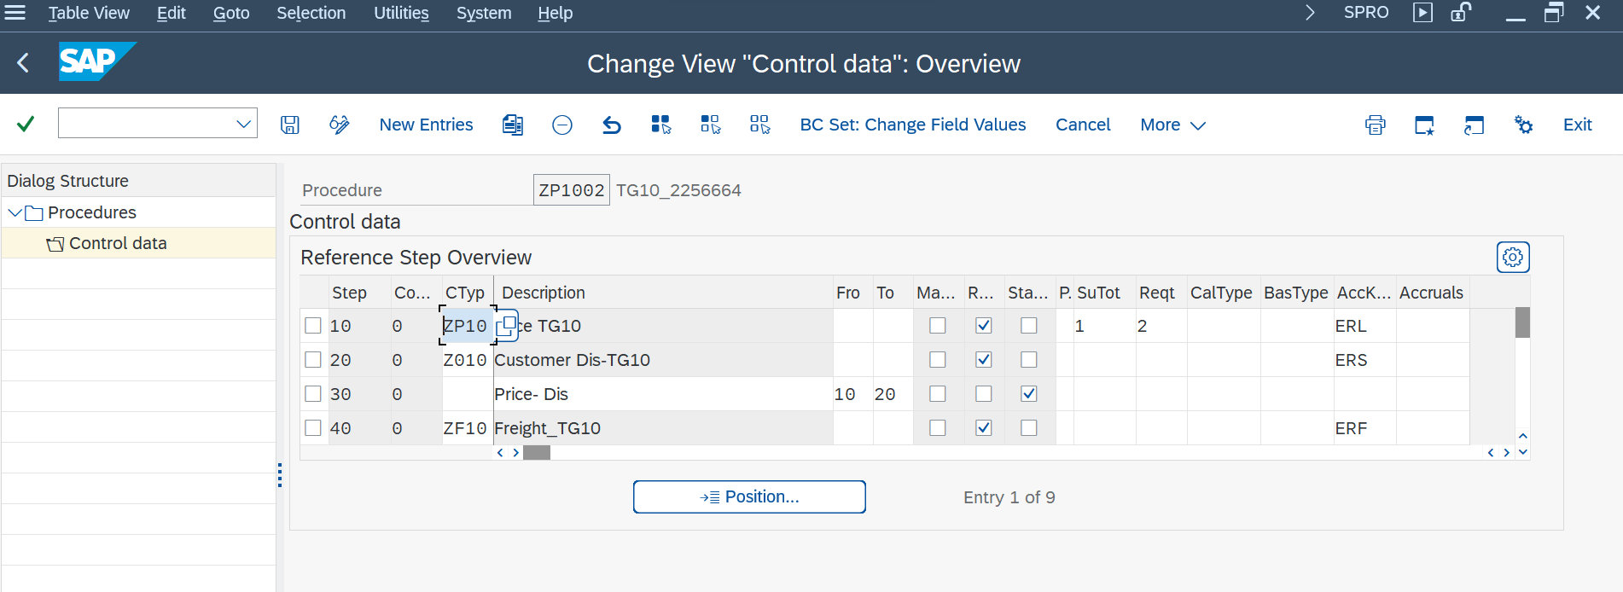

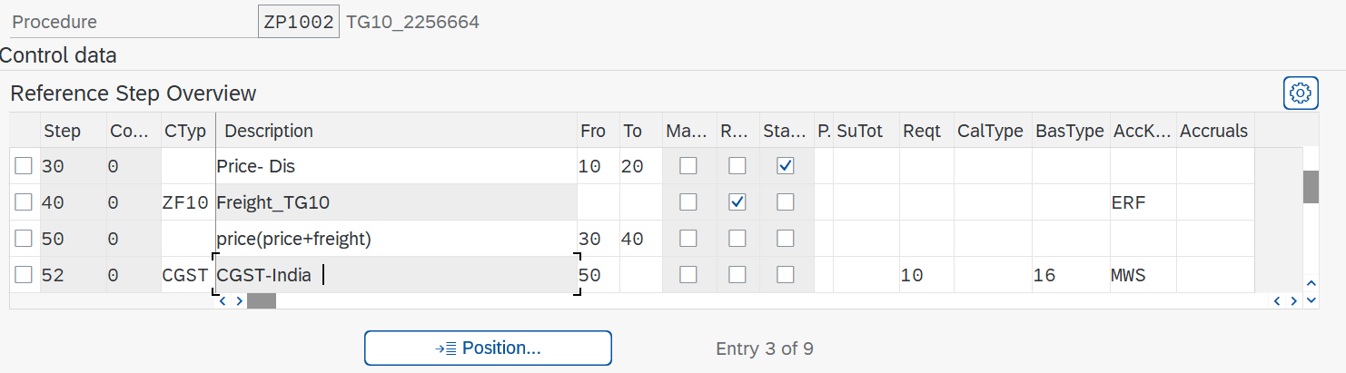

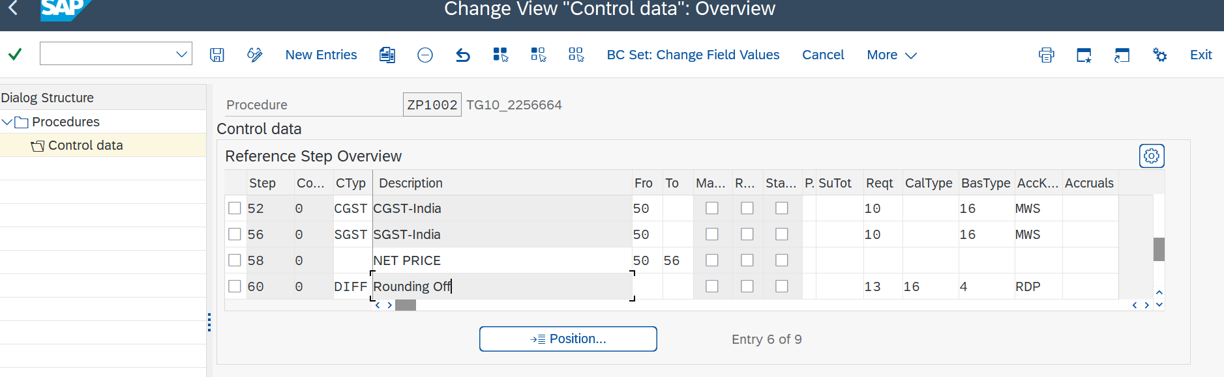

These are the pricing procedure determinations , by using the new entry option we write the condition types to maintain the pricing procedure here .

Here these 3 are the some sales document types , Item Proposal, Cash Sale , Rush order .

Rush orders and Cash sales are sales document types that are used in the sales from plant process or when the customer needs to pick their goods immediately from the warehouse.

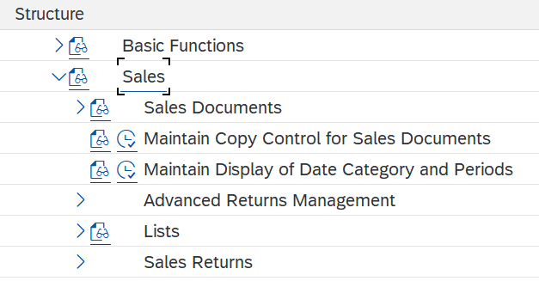

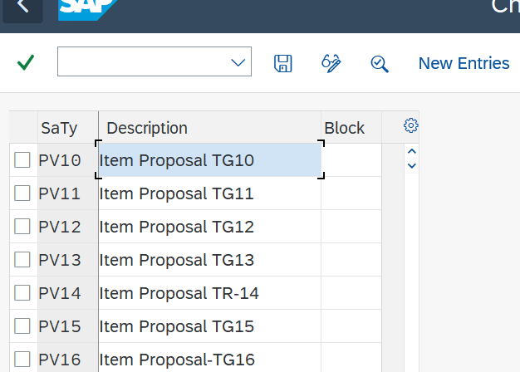

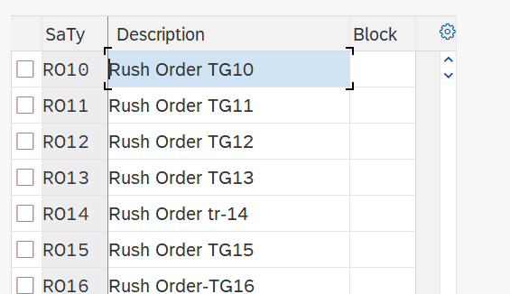

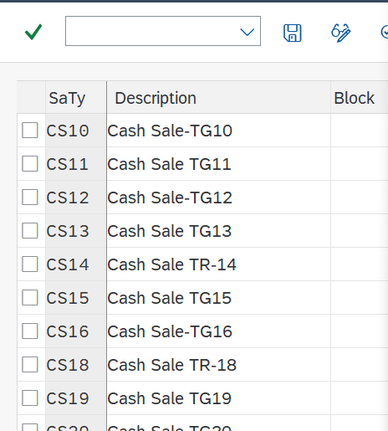

For split (Partial) billing , need to give **K** in item cat .

Billing relevance

Only tax amount comes in tax.

All other amount comes in net value.

Pricing can handle only + - %.

PGI period will end every month. To activate give actual GI date to previous month.

MRP – Material Required for planning

1 sales doc can have only 1 pricing procedure.

1. **Pricing procedure**: Combination of condition types in required sequence to meet business requirement.

1. **Condition type :**Represent properties of pricing condition and describe how condition used.

Have 2 types

* *Header cond type* – It will be applicable for entire doc. We need to enter header condition manually it will not determine automatically bcs **it don’t have access key(sequence).**
* *Item cond type* – It will be applicable for only item.Will **have access sequence**.

Pricing procedure can have n number of condition type but in condition type we can have only 1 access seq.

1 condition can have 1 access seq.

MWST – Globally accepted tax.

1. **Access seq :** search criteria

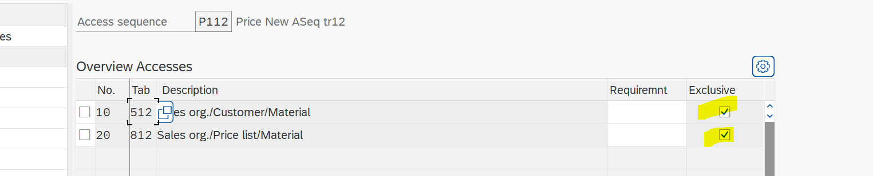

1. **Condition table:** create table from  500 to 999.. (512) and (812)

We need to add some members through field cat..

**After creating table ..also we can add additional field catalog**

1. **Condition record vk11 - to give condition**

Adding header condition type to pricing procedure (We can see header condition only in header detail. and we can only give value in header detail )

Freight – weight(ex:- 1rs per kg) to fixed amount

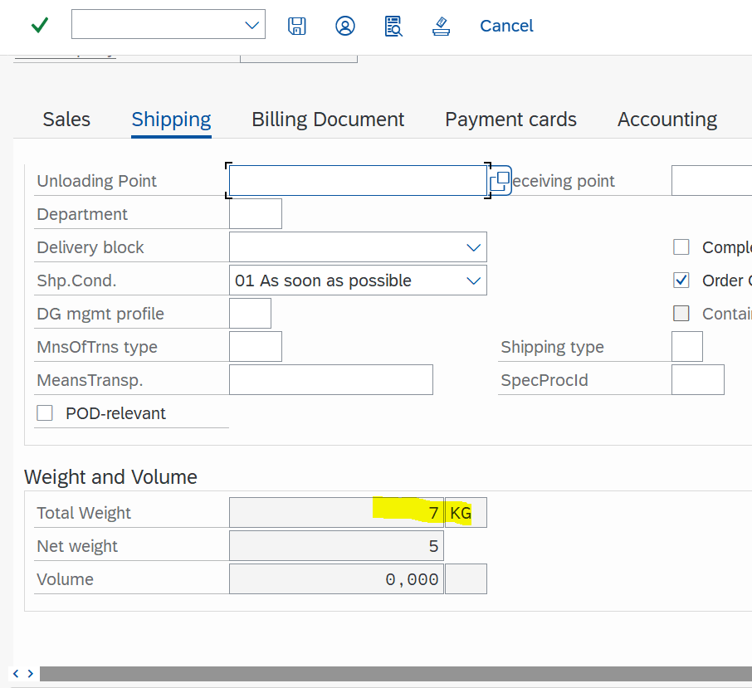

If we gave 2 material and in header we gave 100 rupees for freight, total freight charge will be 200 rs(per material 100rs)..

If we give material 2 quantity also it will consider material only not the quantity so charge will be 100rs not 200..

R100 - 100% discount for material …item category TANN

Freight charge is consider for free item also .

Routine – VOFM – requirement -> pricing -> all in V (sales related)

Manual price condition never have any access seq..

Pricing procedure à Condition type à access sequence -> condition table à in field cat there will be a fields (Condition records).

**Group Condition**: You can use this is feature of a condition type to apply price or discount for a material based on common property.

Ex: if 2 item(material) in same material group and scale quantity for that disc will be 1pc – 1% and 200pc – 2% .

1 item      130pc   01 mat.group

2 item        70pc    01 mat.group

Combined 200 pc we will get 2% discount

Statistical – rough calculation. It will not putting in any account..

**For net value A** in subtotal for credit amount

Workbench req – cross client (**client independent**) changes made are reflected in every client.

We can use **same table in access sequence** but we need to give **requirement differently**.

Access sequence à will be very specific to general. Top is very specific, bottom is general.

Exclusive ->search criteria..if 1st statement is not met then it will consider 2nd statement based on exclusive searching.

 If we don’t mention any exclusive(search criteria) it will take **last one**..

No need to give check for last exclusive.

WR.to **condition class function** in condition type we can **update** in sales order.

**These are the Explanations of 16 columns present in the pricing procedure.**

|  |  |
| --- | --- |
| Steps | Steps for identification |
| Counter | Sub dividing our steps. |
| Condition type | A condition type is **a representation in the system of some aspect of your daily pricing activities**. For example, you can define a different condition type for each kind of price, discount or surcharge that occurs in your business transactions. |
| Description | Describe the condition type |
| From | They can ref the previous condition value. And we can add previous step totals.  (This is used to define how the calculation progress) |
| To | Same as previous |
| Manual | This function enables to allow the condition type to be entered manually also apart from automatic pickup. |
| Required | Mandatory in pricing procedure and cannot be deleted when we give pricing. |
| Statistical | It will not impact on net price.  rough cal. It will not putting in any account. NO account key |
| Print | printing of the values and conditions to the document. |
| Sub total | Carry value from condition type value to table. (Memory).  Ex: if we have 2 pricing procedure common subtotal will be added so that we can see the report based on subtotal.  Table A is for credit link |
| (Routines)Reqt | Basic requirement for conditon type to work. |
| (Routines)Calculation type | Diff cond |
| (Routines)Basetype | Diff condition |
| Account key | This will post the value to the revenue department(account dept) |
| Accruals | Keeping the discount amount  at the end of the term ,we will repay the amount to customer. |

**Direct service:-  without delivery direct billing** can be made by creating material in place of norm give dien service can be any name..dont give material name..

Pro forma invoice cannot be deleted

Billing type f5 – pro forma invoice with respect **to order**..(before delivery we send the invoice to customer)

Billing type f8 – pro forma- **wrto delivery**

Condition type – automatic has priority

Pricing procedure – manually

It takes automatic value. for vice versa also.

If both condition in automatic then we can’t give manually in sales order.

For restricted manually in condition type p.procedure tick manually..show this **info..if we not done any condition record…**

**Imp: Incompletion log**

Transaction flow in sales doc incomplete log check **(can’t go outside without filling the incompletion)** .

**After assign the incompletion.**

**VBKD-BSTDK**

field -> f1 à sales and dist à basic function -> log incomplete -> define ..no assign ->then sales doc header -> sales doc type or12 -> tick incomplete message  .

**Text** – cross client

If text type have any language (EN) then, there is some information present inside. Without open we can get to know.

From delivery to billing text is not transferred until we check in billing -> billing doc type -> delivery text.

**VA51 Item proposal(shift+f11)** à is the functionality in SAP which gives an options at order entry to pull out all the required items/ product range to sale order with a single entry.Document type–cust ->give item proposal number -> va01 -> give cust -> edit -> additional function -> propose item -> default with quantity or any other 2 option... In cust mast we need to give item proposal number.

**Material determination vb11(**no exclusion for access key**)** : spro à sd -> basic func -> material determination -> maintain prerequisites -> display condition table(011) -> check access seq,…

**Exclusion(b001 type)** –. Material or lists of material excluded for the customer.

**Listing(a001 type)**  - Lists of Material is specified for the customer .

**Free goods determination**(exclusion is not there in access seq ) – sale doc, dchl, dv,cust pri.p, doc.p.pro, procedure(NA0001) ..Same as pri.pro(access seq,cond type…). Item cat usage **free goods- Tann** .

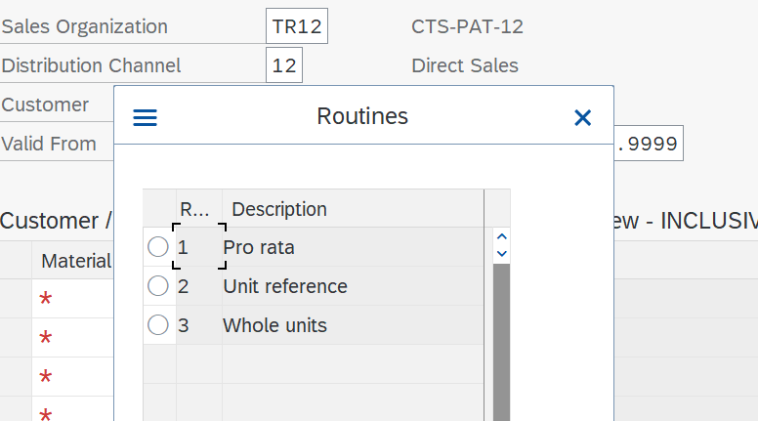

**Account determination :**



**Tax determination criteria** – departure country, destination country (Ship to party) , Customer tax classification(every partner have their own tax classification), material tax classification

Priority rule (determine vat regist no to sales doc)

1. Blank status:

* Rule 1 – Payer (If different from sold to party )
* Rule 2 – ship to party (if sold to party don’t have tax determination )
* Rule 3 – sold to party.

1. Status A: Sales tax identification(According to tax destination country) and tax classification  comes from sold to party.

1. Status B: Sales tax identification (According to tax destination country) and tax classification comes from payer.

For customer tax classification – liable for tax, tax exempt

For material tax classification – full tax rate(10%),half tax rate(5%), tax exempt .

(For Defence persons or organizations Tax is Exempted. )

Tax relevance for master record

Customer Taxes : (INTX)(billing tab)

Tax class 0 – Tax exempt

                 1 – Taxable

Material Taxes : (INTX)(sales org 1)

Tax class 0 – Tax exempt

                 1 – Taxable

Report – in sap fav menu – sales information system – information system- (customer based, material based, sales org)

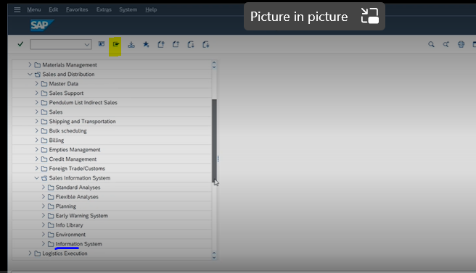

**Credit management**

Assign the credit limit for the customer

Customer are classified as high risk, low risk, medium risk(for automatic not for simple check).

Credit management have 2 type

* Simple
* Automatic credit check

Credit process

1. Centralized credit process – different company code have **only one** credit control area.
2. Decentralized credit process- different company code have **different** credit control area.

**Credit control area** – who are responsible to perform credit activity also called credit dept..**FI consultant responsibility**

Goto sd - > basic func -> credit management/risk management **-> assign sales doc to simple or automatic check** -> then item cat check **credit active** in check box

Credit limit

1.Credit control area

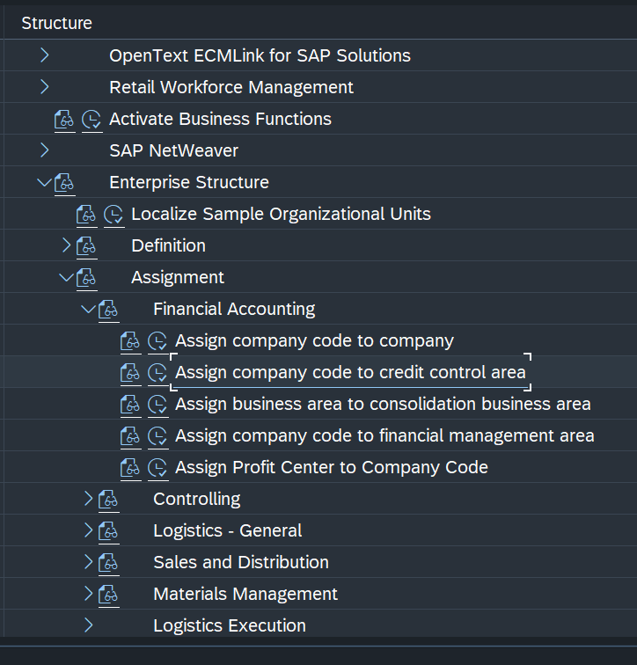

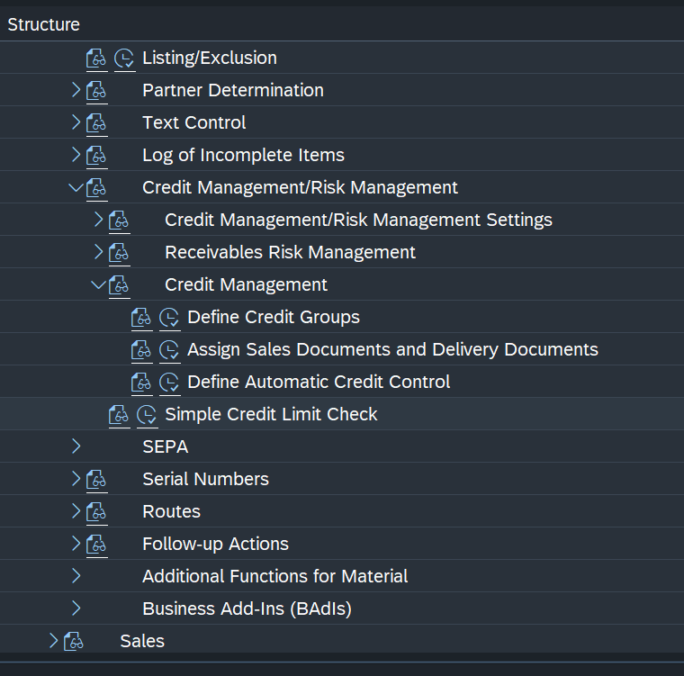

CHECKS(OKV8)

Open orders ------- not moved to next step

Dynamic-------Horizon--------period 1 month

Document value----------maximum doc value------it should not exceed the limit

Open items ------ controlling the date of open

FD32 -------- customer credit management

FD31-------t-code does not exits because for the customer the account created with null value

**Link btn pricing and credit** management -> in pric.procedure subtotal must **be A for net value**

**Automatic credit check**

Risk management – high risk, medium, low risk

If we remove risk from in automatic cr control def then for tht customer cr control is excluded.

**Credit group** – it specify where we have to block, in order level, delivery level, PGI level. **SD consultant responsible**

1. Sales order, 02 – delivery, 03 – goods issue.

**How automatic credit control area determine**

Credit control area + risk cat + credit group.

**Vkm3** – is used to release the sales order which got credit exceed.

Static – we can select open order value and open del

Dynamic – we can create 1 month horizon. we are giving 1 month time for payment. we can create sale order over 1month whatever the price. We can’t create within horizon any sale order.

Doc value – if we set 2000 as doc value even if cust credit lim is 20000, we can’t exceed 2000.

Critical field – fields like cfr, additional value date, fixed value date and payment term cannot be changed. if we check critical field.

What happen when pgi is done? and billing?

PGI will be done in the delivery after picking the goods from the storage location.

-->The PGI will do to change owener ship of the goods from the company to the customer who has ordered that goods.

-->While doing PGI in SAP two transactions will take place.

1. Warehouse stock of the material is reduced by the delivery quantity· 2. Value changes are posted to the balance sheet account in inventory accounting·

3. Requirements are reduced by the delivery quantity ·

4. Goods issue posting is automatically recorded in the document flow

**Output determine** for

* Sales order , billing, delivery.

This is also based on condition technique.

Inquiry are internal doc so we are not assign output doc.

Quotation std cond type – AN00 for printer

Order std cond type – BA00 for printer

Delivery cond type – LD00 – cust 100532

Packing  - PL00

Invoice – RD00 for print and email we have to create

For cash sale invoice generated automatically o/p type is- RD03

NAST is the table and NACE is t.code(to check the o/p types).

Spro -> s&D- >basic func -> output control -> output determination

**Condition technique** – (specific to general) Is procedure to determine condition record to sales document

**Access to condition** – follows condition technique else it will take from customer master

Condition record for sales doc for o/p – vv11

Order  -- table 007 –access seq 0002 – Maintain o/p type--V10000 procedure

Assign à sales doc type – output proced – output type(ba00)

**MTS** – made to stock- based on forecast and historical report they will produce goods. Ex: Small shop .

**MTO** – made to Order – based on Order creation they will prepare and produce goods and it will trigger MRP and it will trigger check the stock req if not there it will purchase and once all done it will come and sit as special stock **E** .example rolls royce

In made to order scenario we always give future date for delivery so there will be **2 schedule line.**.

z...

**Scheduling Agreement** (VA31): Agreement btn company and the customer for supplying goods for particular quantity with particular validity date and predefined delivery type.

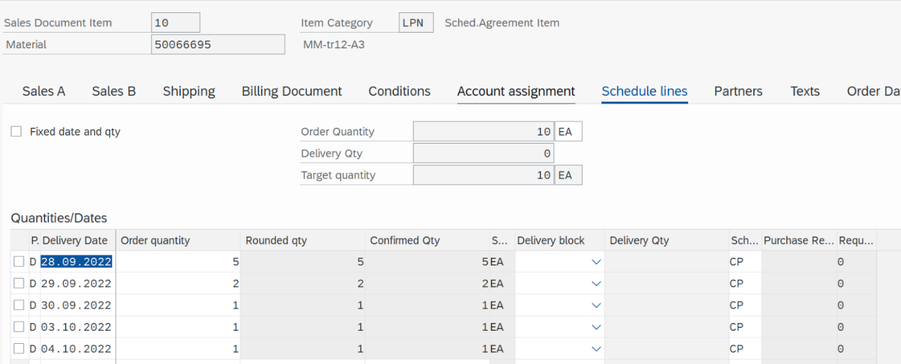

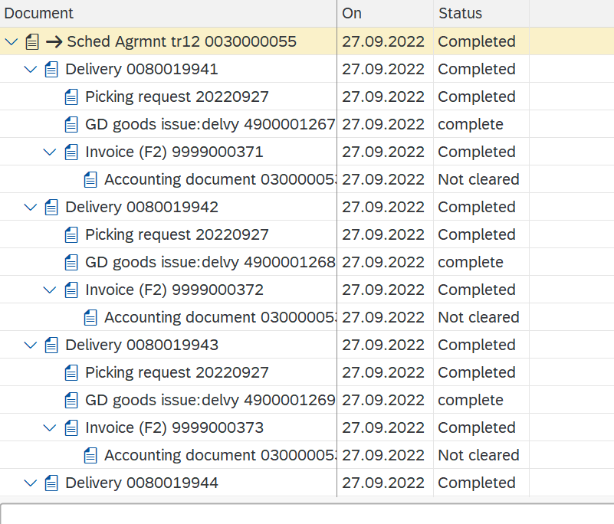

**Contracts** (va41)

**Quantity contract –**

Quantity contract is used when the demand of that particular product or material is very high than the available supply then QC is used. Like we can assign **per** customer only 10qty.

**Release order**: when we create sales order with reference to contract.

We can’t create delivery directly for contract 1st we need to release that order than we can create deli.

**Value contract material specific (wk2 / wk12): ref the contract**

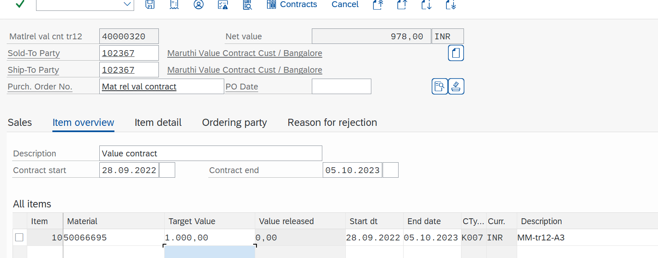

After 1 sale ord created with ref to contrt..we can see value released

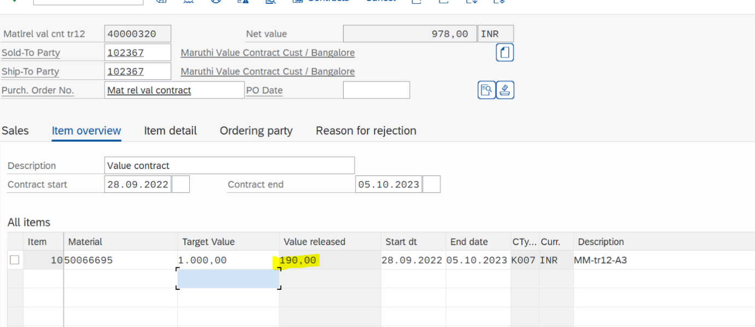

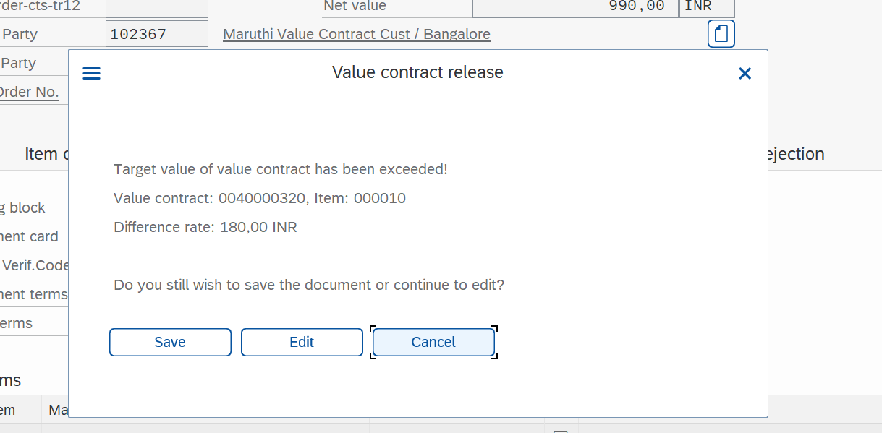

**Value contract for general (wk1 / w112):directly we need to create order..**

1st we need to create assortment module there we will specify list of material(wsv2 tcode, ASM-1 name).

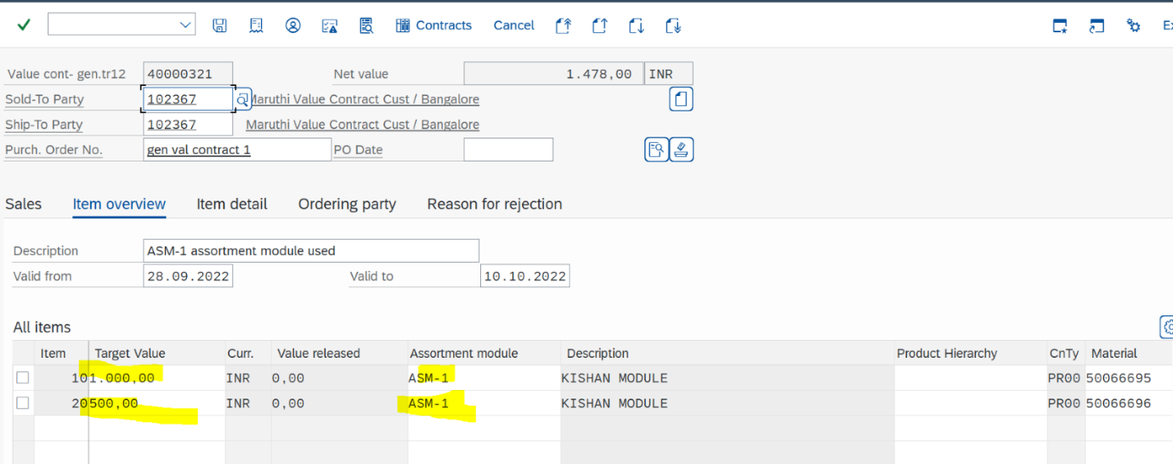

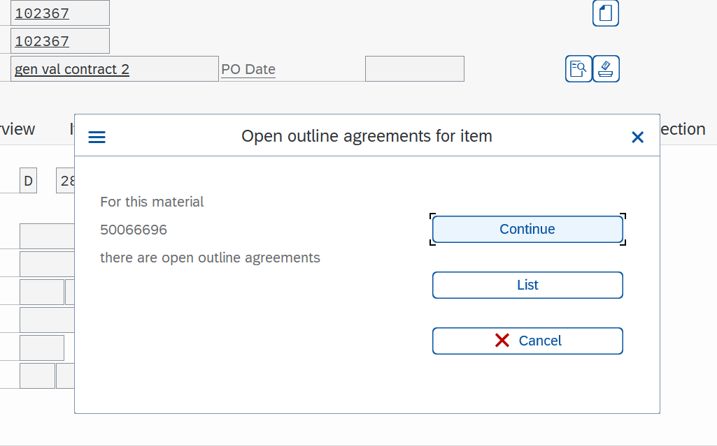

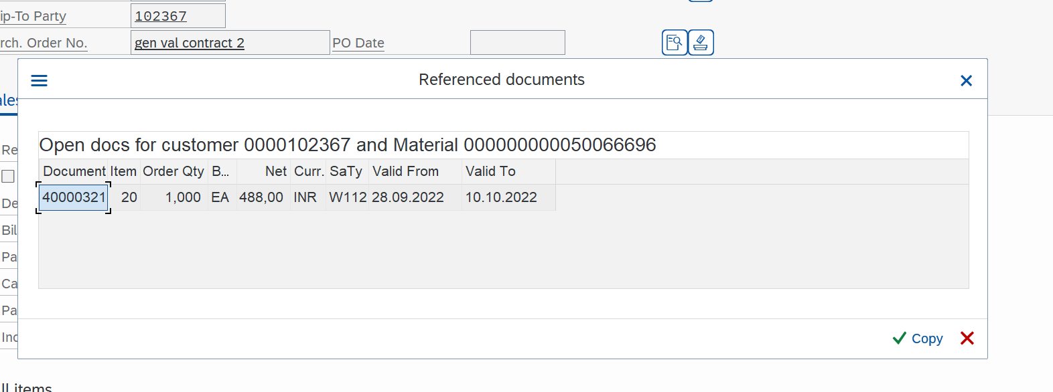

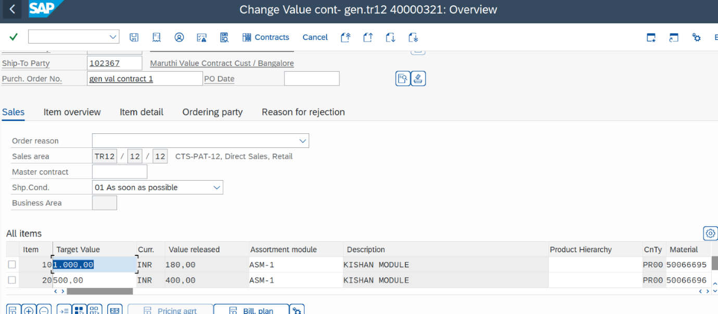

**Difference between contracts and scheduling agreement** ?

In sch agreement, sch line will be there and system will check target qty with sch line qty.

delivery is created w.r.t sch agre.

where as in contract, no sch line. release order is used to release the contract item/value. and delivery, billing

**Third party :**

**3rd party (It.group = BANS(**sales org 2**), system determine it.cat = TAS)**

**Scenario when we go to 3rd party**

* When stock is not available
* Company don’t produce product but wants to sell that product.

Types

1. With shipping notification(both migo and miro)
2. Without shipping notification (only miro)

**Without shipping notification (miro- vendor invoice)**

If billing relevance is **F(**item category**)** then comp cannot create invoice to customer. check po number automatic.

In item cat- TAS, sch cat- CS

**3rd party don’t want sch line cat but we are using that bcs to create purchase requisition.**

CS:– order type NB(checks in sch line), it determine Purchase requisition generated, Acc.Ass.group 1 means it will create dummy inventory doc(not assigned to account)

Invoice based on Order --- OR to f2

Copy invoice from miro to invoice so bill – F

Without miro we cannot send invoice to customer(copy control requirement is 012 in item level. OR to F2..{VTFA tcode} )

**With shipping notification(migo- shipping notification to company)**

Migo(goods reciept) will not effect company account, dummy goods receipt then Miro(invoice verification)

Migo – goods receipt, mm-fi integ

Miro – invoice verification, movement type 101

Since the delivery is not in our control in the case of third party order processing,

1. Before creating the invoice to our customer, it is always good to check how much quantity was invoiced to us by the vendor. This can be possible if MIRO is done. If this kind of checking is not required, the billing relevance field in item category can be changed accordingly, as explained in the above post.

2. During MIRO, we should cross check the quantities invoiced by the vendor and the quantities actually sent to our customer. This check is possible if MIGO is followed. This will identify the differences between the quantity delivered and the quantity invoiced by our vendor. The check box **GR** in the purchase requisition specifies whether MIGO is required or not.

**The booking of MIGO is done by the logistic department, where the material is received. The booking of MIRO is done by the Finance department.**

**IDOCs – intermediately documents**

**Idoc**s is collection of segment and segment is collection of field

And has 3 layers –

* Control records – technical info
* Data records – segments
* Status records – message

3rd party

Sales order va01 – purchase requistion – purchase order(purchase org, vendor must be created) – migo – miro(Invoice verification) – invoice.

For vendor creation xk01

**Stock transfer order**

Intra --- doc type UB---1 company 2 plants

Inter---doc type ----NB----- 2 companies --2 plants -- 2 document -

647 single step

641 two steps

(i). 2 plants from same company code

(ii). Material extended to 2 plants

(iii). Define plants as customers

(iv). Assign PO type to plant "UB"

(v). "Shipping data" Tab should appear in PO

If shipping data is available then u r doing everything right

Shippig tab is the proof that you made sto

Stock transfer order type --UB (PO type)

ME23N-------PO-------Shipping data in line item level

**DOCUMENT TYPE : PO**

ME21N-------change standard PO-------

Me2n----purch.documents

VL!10**B----delivery**

**MB5T**-----stock display

**Contracts**

VA41 ---Tcode

It's like a sale order , we will specify the quantity of the materials and customer details in the contract  va41 t code .

Here after creating the contract we will get the  contract number .

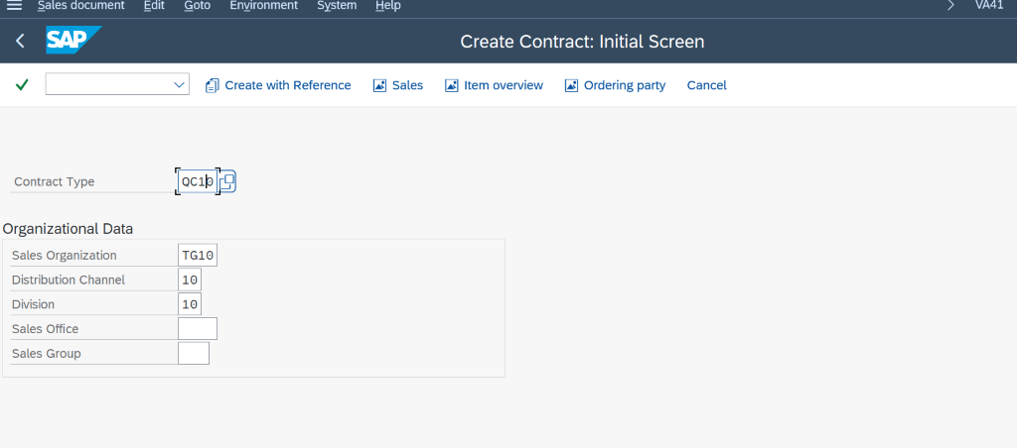

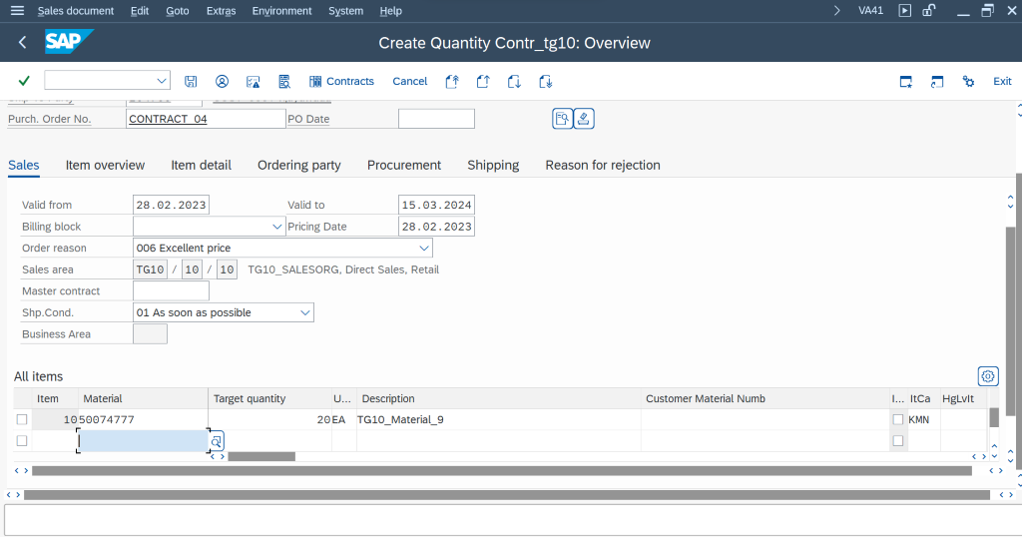

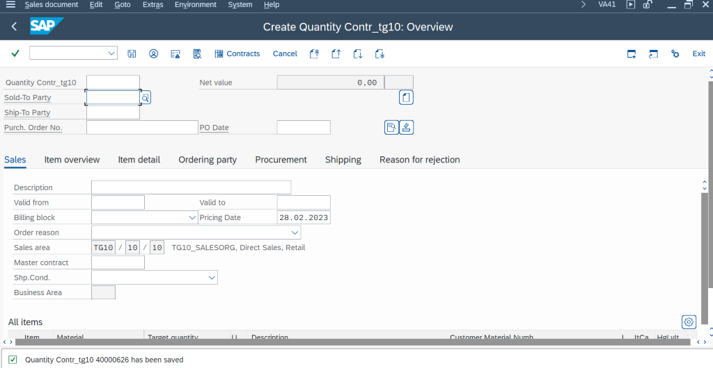

Now create sale order with this Contract number  as a create with reference .

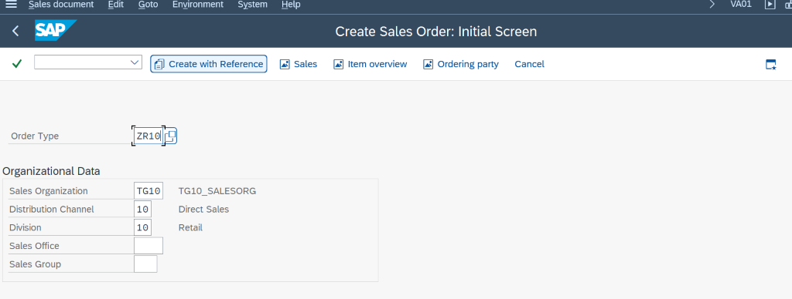

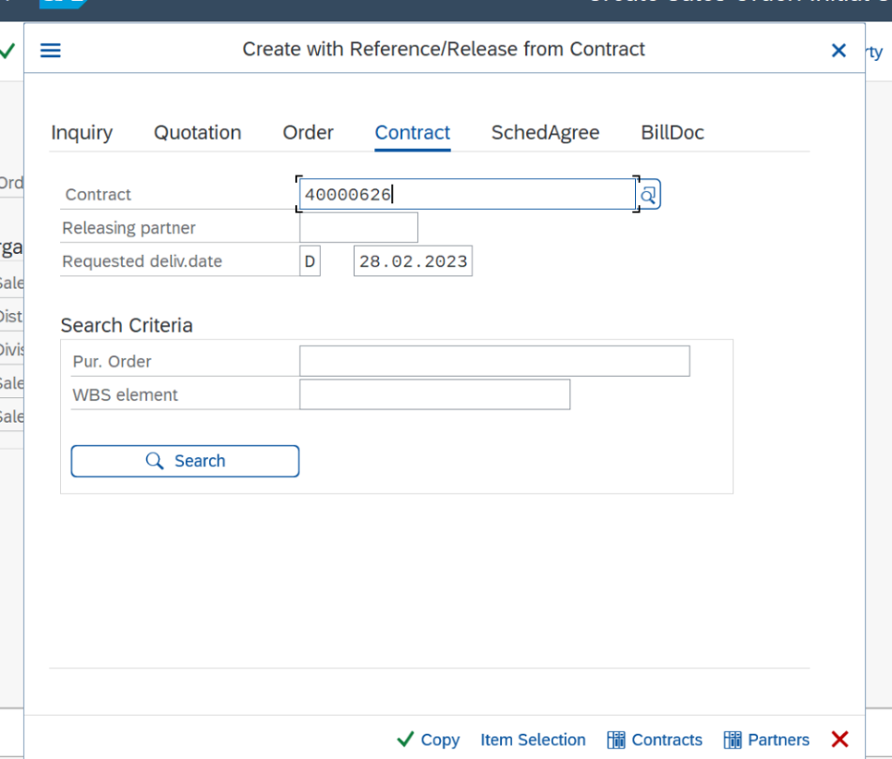

Now the data from the contract will come automatically  to the sale order from the contract agreement by giving the contract number .

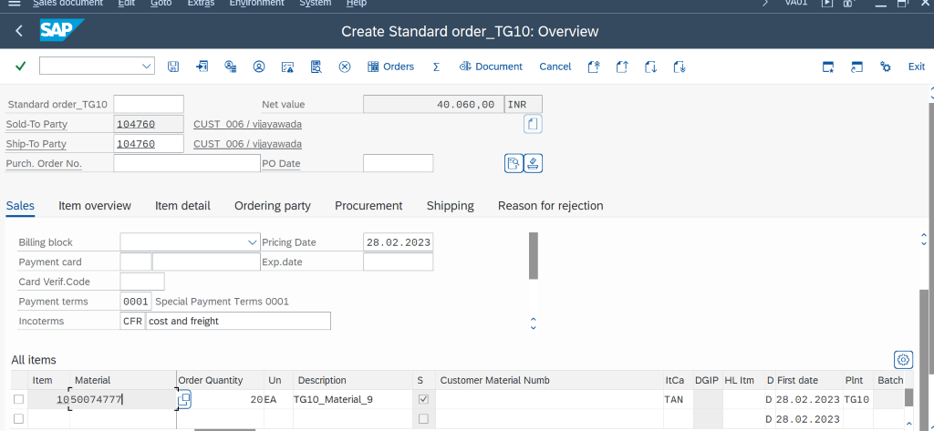

All the data from the contract has came to the sale order , now we have to give the purchase order number and check for the incompletion log and save the document .

This is how the contract works  and all about the contracts ..

**SAP SD – Questions**

1. What are the 5 main components of ERP/SAP?
2. What are the 3 things that ERP/SAP mainly optimise?
3. What is the latest version of SAP? Also, the version of frontend.
4. What is R/3 Architecture?
5. What is the 3 types of Industries?
6. Name few modules of SAP.
7. What are 2 broad classifications in SAP consulting?
8. Which is the Core Module in SAP?
9. What do you mean by Configuration Customisation?
10. Explain about SAP Landscape.
11. Definition off Supply Chain Management.
12. What are the 4 important components of SD Module?
13. What do you mean by Customizing / Workbench Transport Request (TR)?
14. Explain 5 phases of SAP implementation methodology.
15. What is System Gap?

**Organisation Structure**

1. What are the 2 main things need to be done while creating SAP Org Structure?
2. What is the important Org Structure link between SD and material master?
3. What is the important Org Structure link between SD and FI?
4. What is the important link in Org Structure which allows withdrawing stock from Plant?
5. How is shipping point Determined?

**Customer master**

1. What are Tcodes to create customer master?
2. What are the 3 views in customer master?
3. What is the importance of region in customer master?
4. What is the Company Code view mean in customer master?
5. What is the importance of customer pricing procedure in customer master?
6. What is the link between customer master and pricing procedure?
7. What is the importance of exchange rate in customer master?
8. Where do you specify industry in customer master?
9. What is the importance of shipping condition in customer master?
10. What is meant by pod?
11. What are the important fields in billing view in the customer master?
12. What is meant by Incoterms and Payment Terms?
13. Where do you see the Account group in the customer master?
14. Explain partner function in the customer master?
15. There can be many sold to party in customer master T/F.
16. Where do you see the list of customers?
17. What is VD01 FD01?
18. While creating a customer not able to see the company code view in the customer master? Reason.
19. How do you make fields suppress/optional/mandatory/display in customer master?
20. What is the purpose of Account Group Explain?
21. What are the steps to create new doc type and an order with the new doc type?

**Material master**

1. What is the Tcode to create material master?
2. What are the modules involved in creating material master?
3. What are the views pertaining to SD module?
4. What is meant by division in material master?
5. What are the important fields in material master linked to Shipping point determination?
6. What type of pricing is given in Accounting1?
7. What is meant by moving average price?
8. How do you add a missing view to the material master?
9. Where do you See the list of material?

**CMIR**

1. What is the use of CMIR?
2. What are the Tcodes related to CMIR?

**Transactions**

1. What is meant by O to C Cycle in SAP?
2. What are called Sales Documents in SAP?
3. List down the Tcodes from Inquiry to Billing Documents. Explain (Forward and Reverse).
4. What is delivery/order related billing?
5. What are the important field/data required to create Inquiry/Quotation/Sales Order?
6. What are the 3 important components of the Sales Document?
7. How do you see the pricing procedure linked to the Sales Doc?
8. What is the use of update button in pricing tab?
9. How is the delivery date fixed in Schedule lines?
10. What is the use of Incompletion Log in Sales Doc?
11. Can we enter material from other division in the Sales Order?
12. How do you view the customer/Material from Sales Doc?
13. Where do you see the username, created date and the doc type in sales doc?
14. Sales doc can be created with or without reference. T/F
15. Sale order can be created with reference to Quotation/Inquiry T/F.
16. What are the default item category in the Sales Order?
17. Sale Order can be deleted without deleting the delivery and billing document T/F.
18. What are the 2 steps involved in delivery Document creation?
19. Where can you see the material doc after creating delivery?
20. Where do you see the different status in the delivery?
21. Name few Movement types.
22. How do you create initial stock in SAP?
23. How do you (PGI) if the Posting Period is closed in delivery?
24. If 2 different shipping conditions are given in customer master and sales doc, which is determined in the Sales Order?
25. What is the default SAP Standard doc type in O to C?
26. We can create Sales order by entering Customer material T/F How?

**Pricing**

1. Explain how pricing works in SAP?
2. What is the use of condition table in SAP?
3. What is the use of condition type in SAP?
4. What is the use of Access Sequence in SAP?
5. What is pricing determination?
6. What is the purpose of document pricing procedure and where is it?
7. Manual condition has Access Sequence T/F
8. Explain 16 columns of Pricing Procedure.
9. What is the purpose of accruals in pricing procedure?
10. What is the purpose of account key?
11. Tables can be created below 900 T/F
12. In access sequence same table can be repeated T/F Reason.
13. What is meant by header, item group Condition?
14. How do you set manual entry in Condition Type?
15. Where do you maintain Condition records?
16. What are the mathematical calculations handled in standard SAP?
17. Condition type values can be entered at item/header level T/F.
18. What is the important step while entering the header condition?
19. While creating condition record pricing, the previous pricing is deleted. T/F Reason.
20. Where/How do you setup price for Scales for both ascending and descending?
21. Billing Doc can be deleted from SAP T/F Why?
22. Billing Type which is not posted to accounting?
23. Explain important fields in Sales Doc type.
24. How do you check duplicate Po number in the Sale Order?
25. How do you check the material division in the sales order?
26. What is the Doc Category of the Sales Order/ Delivery /Billing?
27. What happens when lead time is given in Sales Order?
28. What happens if you don’t give default delivery and billing types in Sales Order?
29. What is the purpose pf status profile?
30. How do you insert 2 different sales doc type in sales order?
31. Explain internal/ External number range?
32. What are important fields in the item category?
33. What are important fields in the Schedule Lines?
34. How do you trigger automatic PO from the schedule lines?
35. What is the difference between normal and 3rd party schedule line?
36. Name some doc types in SAP
37. What are Tcodes for Credit Memo/Debit Memo/Scheduling Agreement?
38. How do you change Account group for a customer master?
39. Explain Consignment Process with Item Category/Schedule Lines and Movement Type?
40. Explain Scheduling Agreement with Item Category/Schedule Lines and Movement Type?
41. Explain Returns / Credit Note / Debit Note.
42. What are important fields in the item category?
43. What are important fields in the Schedule Lines?
44. How do you trigger automatic PO from the schedule lines?
45. What is the difference between normal and 3rd party schedule line?

**TPO:**

1. What is Third Party Sales?
2. What are the different names for 3rd party sales?
3. How is item category TAS determined in TPO?
4. What are the schedule lines in TPO?
5. How is automatic PR generated bin TPO?
6. What is the complete TPO flow?
7. Can Billing Doc be completed without completing MIRO? Explain with reason.
8. How is Schedule line dates determined in TPO?
9. What is the Importance of BANS in Material Master?
10. What is the purpose of MIGO in TPO?

**Tax:**

1. How is TAX determined in Sales Order? Explain the process.
2. What is the purpose of tax classification in Customer/Material Master?
3. How do you analyse the missing tax value in the sales order?

**Free Goods:**

1. What are Free Goods?
2. What is Inclusive/Exclusive in Free Goods?
3. Explain calculation rules in Free Goods.
4. What is the item Category determined for free goods in sales order?
5. How are free goods supplied at zero cost?
6. How do you activate free goods?

**Inter Company Process:**

1. Explain Inter Company Process.
2. How are two billing docs created in IC process?
3. What are the important pricing components in IC process?
4. What is Item Category/ Schedule Category for IC Process?
5. What is the movement type for IC Process
6. What are the Configuration Steps for IC Process?

**Credit Management:**

1. How is Credit Management Activated?
2. Where do you give Credit values for a customer?
3. What is the link between Pricing Procedure and Credit Management and Payment Terms?
4. What is the importance of Credit Group?
5. What is the importance of Risk Category?
6. Explain OVA8 Settings.
7. What is the difference between Doc Value and Credit Limit?

**Output Determination:**

1. How is Output Configured?
2. Where do you maintain condition records for Output Determination for Sales/delivery/billing docs?
3. Where do you see Output for any Doc?
4. How do you control output management for different scenarios?
5. How do you configure for an IDoc/EDI?
6. What is IDoc?

**Text Determination:**

1. How is Output Configured?
2. How do you make Text Determination mandatory for any Doc?
3. Delivery Text not copied to Billing Doc. Reason.

**STO:**

1. How do you configure STO Process?
2. What is the proof that STO is Configured?
3. How do you transfer STO price to Proforma Invoice?
4. What is one step STO?
5. What is the Doc Type for STO?
6. What is shipping data for plants in STO?
7. Where do you see the In Transit Stock in STO?

**Tables:**

1. Name all Tables (at least 5 for each doc type).
2. What is the important link table?
3. How do you prepare FS?

**Availability Check:**

1. How is Availability Check done?
2. How is it transferred to requirements?
3. What is the basis for Availability check?
4. What is Backward Scheduling?
5. What is Forward Scheduling?
6. What is Checking Rule?
7. What are the parameters for Availability Check?
8. What is the setting done in Schedule Lines for Availability Check?
9. What happens in MTO and MTS Order in Availability Check?

**MTO/MTS:**

1. What is MTO/MTS Process?
2. What is the difference between MTO/MTS?
3. How do you identify whether it is an MTO/MTS?
4. Where is the setting for MTO/MTS?

**Copy Control:**

1. What is Copy Control?

**Incompletion Log:**

1. How to setup Incompletion Log for Sales Order/Delivery/Billing?